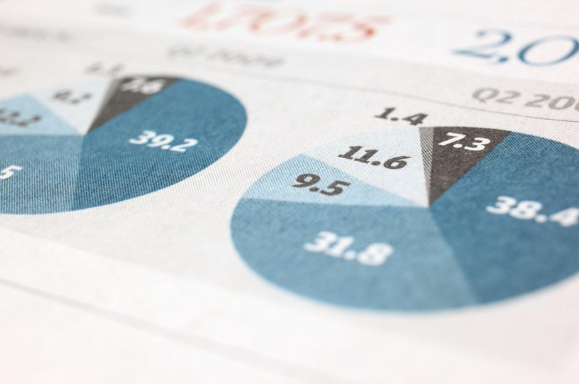
Engineering Productivity Strategy – The BASE (Benchmark, Automate, Shift-Left, Engineer) Framework
Leveraging Engineering data to inform strategic decisions and generate actionable insights that improve outcomes beyond subjective judgement
MeTS Participation Private Limited | 2/24/26 | The BASE Framework

Table of Contents
1. Executive Summary: 3
Bird’s Eye View 4
2. The Approach: Our Engineering Maturity Journey 6
2.1 The Three Maturity Phases (Our Roadmap) 6
2.2 The Operational Rhythm (How We Master Each Phase) 6
3. Phase 1: Crawl (Visibility & Basic Hygiene) 7
3.1. Standardize & Quantify the Work 7
3.2. Define Metrics & Align: Keeping It Simple 9
3.2.1 The "Tension Pair" & The Guardrail (Our Starting Metrics) 9
3.2.2 Aligning on "Duration" vs. "Cost" (Cycle Time vs. Effort) 10
3.2.3 Aligning on the "How": Tooling & Process Standards 10
3.2.4 The Tension Pair in Practice: How We Measure 10
3.2.5 Role Mindsets: Partnering for Flow 11
3.3. Visualize Metrics & Govern: Supporting Flow, Not Auditing Output 11
3.4. Analyze Outcomes & Adjust: The Blameless Diagnosis 12
3.5. Learn & Adapt: Small Steps to Better Flow 13
3.5.1 Bringing It All Together: A Day in the Life 15
4. Phase 2: Walk (Capacity Protection & Async. Flow) 16
4.1. Standardize & Quantify (Pre-Sprint) 16
4.2. Define & Align (The Core Metrics) 17
4.3. Visualize & Govern (Active Sprint) 17
4.4. Analyze & Adjust (The Diagnostic Hypotheses) 18
4.5. Learn & Adapt (Code Review & Handoff) 19
5. Phase 3: Run (Strategic Automation & Architectural Health) 21
5.1. Standardize & Quantify (Pre-Sprint) 21
5.2. Define & Align (The Core Metrics) 21
5.3. Visualize & Govern (Active Sprint) 22
5.4. Analyze & Adjust (The Diagnostic Hypotheses) 22
5.5. Learn & Adapt (Deployment & Accountability) 23
6. The Engineering Automation & Platform Roadmap 25
7. Leadership Governance: The Pact of Trust 26
7.1. Guarding Against Perverse Incentives (Metric Integrity) 26
8. Target state 27
9. Appendix 28
9.1. Role Definitions: Partnering for Flow 28
9.2. The Daily Closed-Question Huddle Script 30
9.3. The "Definition of Done" (DoD) Checklist 31
9.4. Metric Integrity: Safeguarding the "Pact of Trust" 32
9.5. Glossary of Metrics 33
9.5.1 Discovery & Requirement Flow 33
9.5.2 Design & Architectural Integrity 33
9.5.3 Delivery Velocity & Flow 33
9.5.4 Quality 33
9.5.5 Stability (High-Compliance Focus) 34
9.5.6 Predictability & Planning 34
9.5.7 Business & Developer Alignment 34
9.5.8 Project 35
9.6. The Tension Pair in Practice: Calculation Examples 36
9.6.1 Measuring Cycle Time (Flow) 36
9.6.2 Measuring First-Pass Yield / FPY (Quality) 36
10. The Future Horizon (Phase 4: Scale & Optimize) 38
10.1. Analyze & Adjust: The FinOps & Cloud Cost Blind Spot 38
10.1.1 THE FINANCIAL BLIND SPOTS (The Profit Leaks) 38
10.1.2 THE GOVERNANCE MANDATE 38
10.1.3 THE ENTERPRISE HYPOTHESES (The Sensors) 38
10.1.4 THE STRATEGIC ROI -"Learn & Adapt" Habits 38

Executive Summary:
The Mission
Enable sustained, measurable gains in engineering productivity by separating “how we work” from “where we stand”. This progression would be guided through by a three-phase maturity journey focused on visibility, flow, and automated governance.

Strategic Overview
The high performance/sustained high productivity culture through all the weathers needs a shift in mindset. Transforming from the current “subjective” mindset into a data backed “objective” mindset will be a big change. This will hence be a 3-phased evolutionary approach (Crawl, Walk, Run) detailed throughout this document.

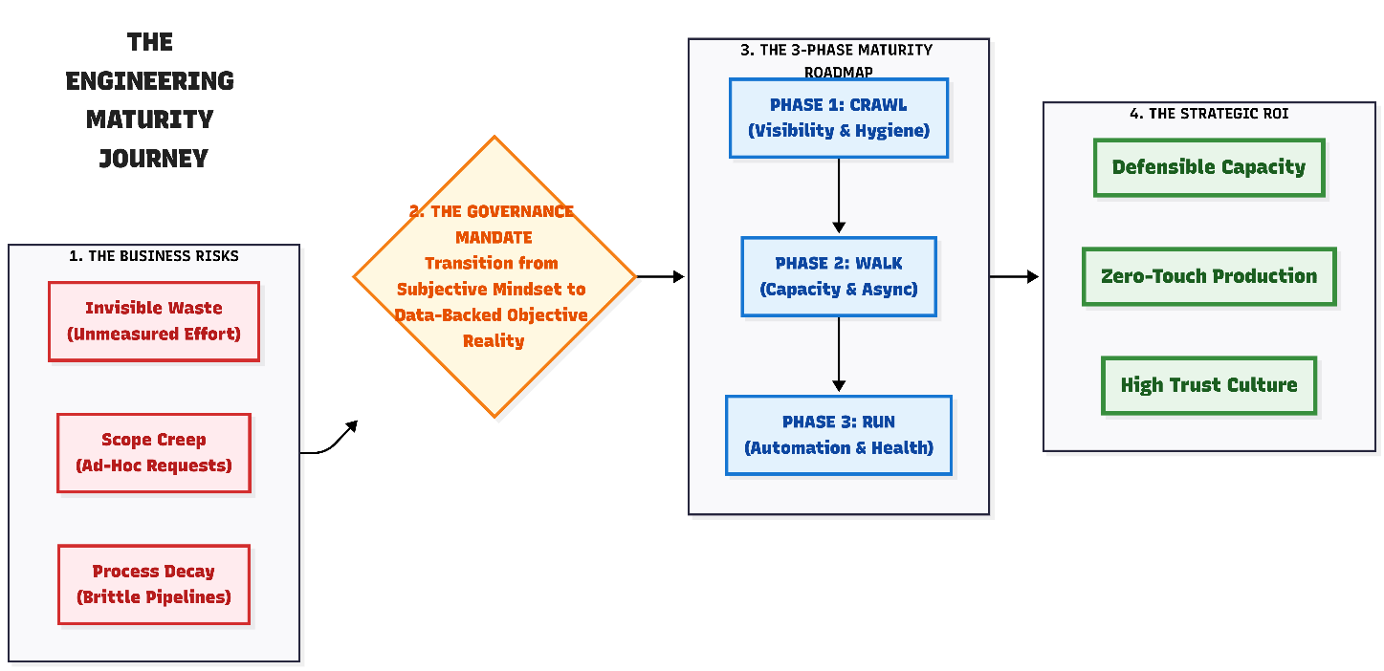

Operational Rhythm
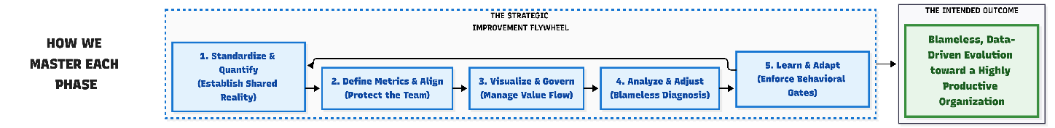
Each phase will have to be run/governed as a project in itself. The proposal is to have a 5-step loop within each phase and govern the outcomes
- Standardize & Quantify the work
- Define Metrics & Align
- Visualize Metrics & Govern
- Analyze Outcomes & Adjust
- Learn & Adapt
The intended outcome is to have blameless, data-driven evolution towards a highly productive organization
Governance and Culture
While we embark on this large scale transformation journey, it is important that leadership and management compliment the transformation with following behaviors –
- Pact of Trust/Commitment to psychological safety : Metrics diagnose process friction, not judge individuals
- Safety first: No punitive individual metrics; focus on systemic improvements
- Data governance: Aggregated squad-level view; protect against perverse incentives

Desired Outcomes
The cultural transformation is intended to bring the following into the organization –
- High performance and highly productive culture backed up by data-driven decision-making
- Better capacity utilization, reduction of wastes
- High psychological safety; improved FPY and stable cycle time
- High-speed deliveries leading to better customer satisfaction, improved profitability

Bird’s Eye View
This comprehensive document outlines a structured three-phase engineering maturity journey designed to improve productivity through increased visibility, optimized flow, and strategic automation. It emphasizes a cultural shift to data-driven decision-making, psychological safety, and continuous improvement supported by standardized metrics and governance.
- Three-phase maturity roadmap: The journey progresses through Crawl (visibility and basic hygiene), Walk (capacity protection and asynchronous flow), and Run (strategic automation and architectural health), with each phase building on the previous and requiring mastery before advancing.
- Operational rhythm: Each phase follows a five-step loop—standardize and quantify work, define metrics and align, visualize metrics and govern, analyze outcomes and adjust, and learn and adapt—to drive continuous, blameless improvement.
- Phase 1 focus on visibility: Establishes accurate baseline data by capturing all work on issue trackers, including unplanned tasks, with strict ticket sizing and effort logging to protect team capacity and expose hidden workload drains.
  - Core metrics and alignment: Introduces the "Tension Pair" of Cycle Time (duration) and First-Pass Yield (quality), supported by Capacity Health (maintenance tax) and developer eNPS to balance speed, quality, and team well-being.
  - Governance and culture: Promotes psychological safety through a "Pact of Trust," ensuring metrics diagnose systemic issues rather than individual performance, with aggregated data reviews and protection against perverse incentives.
- Phase 2 enhancements: Builds on visibility by enforcing tactical alignment via "Three Amigos" pre-sprint collaboration, shift-left QA practices, strict pull request gates, and AI-assisted knowledge sharing to improve flow and quality.
- Phase 3 automation and architectural health: Focuses on embedding architectural grooming, dynamic capacity carve-outs for technical debt, automated quality gates in CI/CD pipelines, and managing alert fatigue to maintain delivery speed without sacrificing stability.
- Leadership governance and metric integrity: Leadership commits to non-punitive, aggregated metric use, guarding against gaming behaviors such as rushing code or rubber-stamping reviews, ensuring sustainable productivity gains and team well-being.
- Future outlook with FinOps integration: Plans for a Phase 4 focus on cloud cost governance by treating financial cost as a non-functional requirement, embedding cost estimates in architectural decisions, and automating cost controls to optimize profitability.

The Approach: Our Engineering Maturity Journey
To drive a sustained, measurable increase in engineering productivity without overwhelming the team, we are adopting a structured approach. We separate how we work (our continuous improvement loop) from where we are (our current maturity level)

The Three Maturity Phases (Our Roadmap)
This strategy is divided into three sequential phases. A squad must master the habits and stabilize the metrics of their current phase—passing a strict operational "Gate"—before advancing to the next level.
- Phase 1: Crawl (Visibility & Basic Hygiene): Establish absolute baseline visibility and stabilize our primary Tension Pair (balancing speed vs. predictability/quality). We are moving away from "shadow IT," untracked ad-hoc requests, and chaotic execution to gather accurate baseline data so we know our exact starting point.
- Phase 2: Walk (Capacity Protection & Asynchronous Flow): Transitioning from basic visibility to tactical alignment, disciplined asynchronous execution, proactive quality assurance, and accountable, AI-assisted knowledge sharing.
- Phase 3: Run (Strategic Automation & Architectural Health): Transition from manual discipline to automated safety nets, actively partner with the business to drive product value, and ensure high-speed delivery without falling victim to the Automation Paradox.

The Operational Rhythm (How We Master Each Phase)
Within each of these three phases, squads continuously loop through a 5-step operational rhythm to drive continuous improvement:
- Standardize & Quantify the work: Establishing the shared reality of our effort. This scales from simply putting invisible work on the board (Phase 1) to defining explicit wait-state queues (Phase 2) and enforcing architectural capacity carve-outs (Phase 3).
- Define Metrics & Align: Selecting phase-appropriate metrics to protect the team. We evolve from balancing a basic 'Tension Pair' of speed vs. quality (Phase 1) to tracking PR handoff latency (Phase 2) and long-term CI/CD pipeline health (Phase 3).
- Visualize Metrics & Govern: Actively managing the flow of value. We use our boards and tools to diagnose systemic friction, whether it's unblocking daily tasks (Phase 1), visualizing time-zone latency (Phase 2), or quarantining flaky automated tests (Phase 3).
- Analyze Outcomes & Adjust: Utilizing blameless diagnostic hypotheses. We look at the aggregated data to identify capacity drains, measure the ROI of our AI tooling, and spot brittle architecture, completely avoiding individual audits.
- Learn & Adapt: Enforcing behavioral and automated gates. We translate data into unbreakable habits—ranging from basic "Definition of Done" checklists (Phase 1) to strict PR SLAs (Phase 2) and zero-touch deployment rules (Phase 3)

Phase 1: Crawl (Visibility & Basic Hygiene)

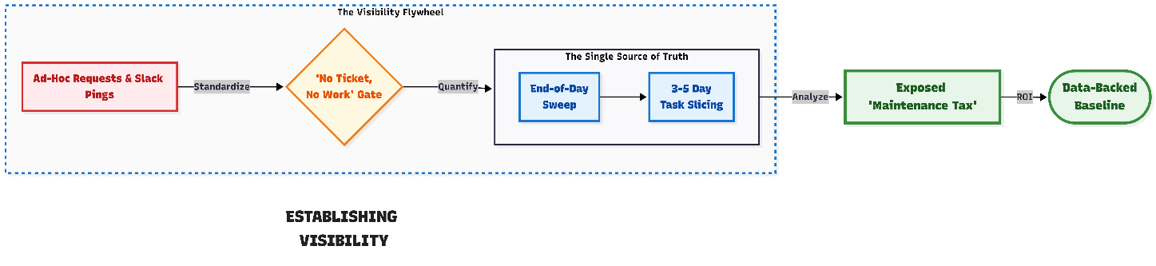

Standardize & Quantify the Work
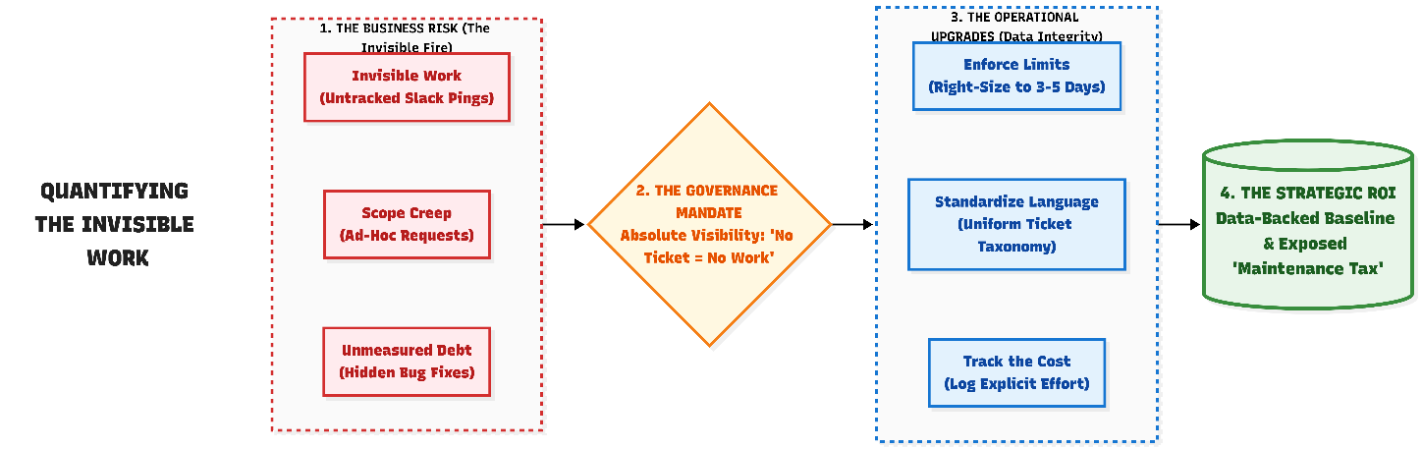
Accurate data is the foundation of our strategy. However, it is highly possible, a significant portion of our team's daily effort is "invisible"—lost in Slack pings, ad-hoc bug fixes, and long meetings. To fix this, our immediate goal is to simply capture reality on our board.

- The Golden Rule: If It’s Not on the Board, It Doesn't Exist
Our issue tracker (e.g., Jira, Azure DevOps) is our single source of truth. If you are doing work, it needs a ticket. This includes feature work, urgent hotfixes, and process overhead. This is not for micromanagement; it is the absolute only way we can accurately capture your "invisible work" and prove to the business exactly where our teams are overloaded.

- Keeping Work Bite-Sized
A ticket that stays "In Progress" for three weeks is impossible to track and demoralizing for the developer. We will agree to a shared rule: a single "Story" or task should represent no more than 3 to 5 days of effort. Anything larger must be broken down so the team can get the psychological win of moving work to "Done".

- Categorizing the Noise
We will use simple tags or a "Type" field to distinguish between planned work (Features) and unplanned work (e.g., Unplanned Production Issues, Ad-Hoc Stakeholder Requests, Cross-Team Assistance, and Environment Troubleshooting). Visualizing this "invisible fire" of daily interruptions serves three vital purposes:
- Internal Reflection: It acts as a mirror during our retrospectives, helping the team identify and resolve self-inflicted process friction.
- Leadership Intervention: It exposes systemic bottlenecks, showing managers exactly where they need to step in to fix broken processes and shield the squad.
- Protecting Capacity: It provides the objective data required to politely push back on external scope creep.
By surfacing this noise, we empower both the team and leadership to systematically eliminate it together—reclaiming those lost hours and redirecting our effort back toward building new, high-value features.

- Capturing the Effort (Protecting Capacity)
Simply creating a ticket tells us what happened, but logging the actual effort (in hours or days) tells us what it cost . We are instituting this practice not to police timesheets, but to mathematically protect the team. Capturing our actual effort enables us to:
- Establish True Capacity: Move away from guessing our bandwidth and establish a realistic, data-backed baseline of what the squad can sustainably deliver.
- Expose the "Maintenance Tax": Definitively prove to the business exactly how many hours per sprint are consumed just by "keeping the lights on" and servicing unplanned requests.
- Defend the Squad: Replace subjective complaints (e.g., "we're overloaded") with undeniable data (e.g., "we lost 45 hours this sprint to environment outages"), empowering leadership to push back on scope creep and negotiate realistic deadlines.
To capture the true cost of our "Maintenance Tax" without breaking developer flow, we operate on the End-of-Day Sweep:
- During the Day (Protect the Flow): When an engineer gets pulled into a quick ad-hoc request, a 15-minute sync, or minor troubleshooting, they do not touch the issue tracker. They simply help their teammate and return to their primary task.
- End of the Day (The Sweep): At the end of the shift, before logging off, the engineer performs a 30-second mental sweep. They estimate the cumulative time lost to random noise and invisible work that day (e.g., "I lost about 1.5 hours today to ad-hoc pings and helping QA"). They log that aggregate time in one single entry against the team's "Sprint Bucket" ticket.
This captures the massive cumulative capacity drain needed to defend the squad from scope creep , while requiring only 30 seconds of administrative overhead per day

- Standardized Definitions & Effort Logging
If every squad speaks a different language, the overarching data becomes meaningless. To ensure organizational alignment, every team must adopt a shared, standardized baseline:

- Uniform Ticket Taxonomy (The Tagging Baseline): Every squad must define work types the exact same way. If squads speak different languages, overarching data fails. We will strictly align on the following tags:

  - Epic / Feature: Large product initiatives spanning multiple sprints.

  - Story: Standard planned product value requiring full grooming and "Three Amigos" alignment.

  - Task (or Sub-Task): The technical breakdown of a Story, or isolated technical chores.

  - Story Defect (In-Sprint Rework): A failure found by QA during the active sprint testing phase. (Crucial: This must be logged as a sub-ticket linked to the parent Story, never as a standalone backlog item. This is the exact mechanism that triggers a drop in our First-Pass Yield / FPY metric).

  - Bug (Escaped Defect): Existing, previously released logic that is demonstrably broken in a live or integrated environment.

  - Minor Enhancement: Evolving maintenance or small logic changes estimated at less than 2 days of effort. (Crucial: This specific tag acts as the trigger for our Phase 2 'Fast-Track' workflows).

  - The "Sprint Bucket" (Maintenance Tax & Unplanned Work): Instead of creating dozens of micro-tickets for daily interruptions, the Scrum Master will create one master ticket per sprint (e.g., "Sprint [X] - Routine Maintenance & Ad-Hoc Support"). All effort uncovered during the developer's "End-of-Day Sweep" is logged exclusively against this single bucket ticket.

- Consistent Effort Capturing: Whether a squad logs effort in hours, days, or points, the unit of measurement must be identical across the team.

This uniformity ensures we are all speaking the same language when we look at our board. It guarantees that when leadership aggregates this data to allocate capacity, balance workloads, or advocate for technical debt remediation, they are comparing apples to apples.

- Keeping the Board Honest (Manual Tracking)
Until our tools are highly automated, we rely on disciplined manual tracking to keep the board updated . To ensure our Cycle Time accurately measures the system's actual wait times, we follow two simple habits:
- Real-Time Statuses for Planned Work: Move your planned feature tickets to "In Progress" the exact moment actual work begins, and to the next state (e.g., "Ready for QA") the moment it leaves your hands.
- The Scrum Master Shield for Emergencies: If a massive "invisible fire" breaks out (e.g., a critical production bug or a sudden staging environment collapse), the developer’s only job is to flag it in the team channel and start fixing the system. The Scrum Master takes the administrative burden. The Scrum Master will create the necessary tracking ticket, tag it as an urgent Bug, and retroactively log the developer's time once the fire is out. We protect the developer's focus during a crisis.

This real-time discipline is the only way our Cycle Time metric will accurately measure the system's actual wait times and friction, rather than just our memory of the day.

Define Metrics & Align: Keeping It Simple
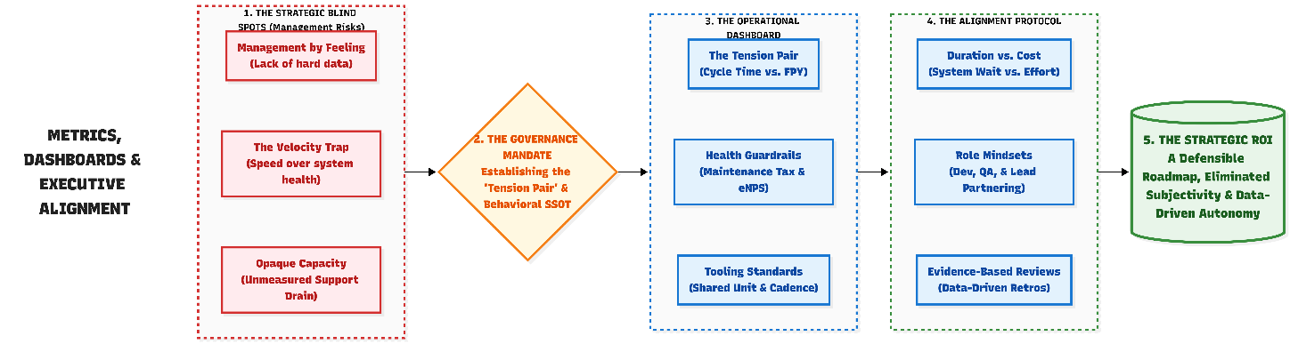
When a team is just starting to visualize their work, the fastest way to fail is to try and track everything at once. We will not introduce a dozen competing data points or complex executive dashboards. Our goal in this first phase is simply to establish a baseline: turning the lights on so we can see how work actually flows through the team.

The "Tension Pair" & The Guardrail (Our Starting Metrics)
Instead of a heavy metric cascade, we will align the entire team around a simple balance: The Tension Pair, protected by a team health guardrail. Cycle Time and FPY are the Tension Pair, while eNPS acts as the protective Guardrail.
Core Metric | Purpose | Formula / Measurement
Cycle Time | Monitoring the time from start to 'Done' to identify friction and wait states. | The sum of cycle times (in md) for all completed tasks divided by the total number of tasks over a specific period
First-Pass Yield (FPY) | Acting as the primary indicator of process quality by tracking work that requires zero rework. | Passed items on first test / Total items tested
Capacity Health  (The Maintenance Tax) | Definitively measuring the exact effort consumed by unplanned work to prove capacity drains and push back on scope creep | Total explicit effort (hours/days) logged on unplanned/maintenance tickets vs. Total effort logged on planned features.
Developer eNPS | Monitoring tool satisfaction and burnout risk to ensure our productivity gains are sustainable. | Net Promoter Score = % Promoters - % Detractors

⚠️ A comprehensive glossary of all available metrics is maintained in the Appendix
⚠️ Other data points like PR Review Latency or Throughput will not be used as targets in Phase 1. They are strictly background diagnostic tools to be used in Phase 2.

Aligning on "Duration" vs. "Cost" (Cycle Time vs. Effort)
To ensure psychological safety, we must align as a team on the critical difference between the duration of a ticket and the cost (effort) of a ticket.
- Cycle Time measures Duration: If a ticket sits idle for two days waiting for a UK requirement clarification, the Cycle Time will be long. This measures the efficiency of our system and highlights wait times.
- Effort Logging measures Cost: The actual hours logged on that same ticket might only be 6 hours. This measures our capacity.
We align on tracking both because they serve different defensive purposes: Cycle Time proves our process is blocking you, while Effort Logging proves exactly how much of your capacity is being drained by the "Maintenance Tax."

Aligning on the "How": Tooling & Process Standards
While individual squads retain the autonomy to organize their daily technical work, the mechanism for capturing effort must be uniform across the teams(s). As part of our alignment, we will agree on:
- The Single Source of Truth: We will strictly define which specific field(s) in our issue tracker (e.g., the native "Time Spent" field in Jira) will be used to log what kind of efforts.

- The Shared Unit of Measurement: We will align on a universal metric (e.g., logging in hours vs. half-days) to ensure we are comparing apples to apples across all squads.

- The Logging Cadence: We will agree on the baseline process expectation—for example, updating effort before the daily huddle—to ensure our data is fresh without feeling like a burdensome timesheet audit.

The Tension Pair in Practice: How We Measure
A common misconception is that these metrics measure individual coding speed. They do not. Cycle Time measures the efficiency of the overarching system. It tracks the entire lifespan of a ticket, including every hour it sits frozen in a queue. If you are blocked for two days waiting for a cross-geography requirement clarification, that delay intentionally inflates the Cycle Time. We want this visibility; it provides the mathematical proof needed to fix organizational bottlenecks, rather than acting as a stopwatch on your keyboard.
Example: Exposing the "Wait" State (The Time-Zone Handoff)
The Scenario: A developer moves a ticket to "In Progress" on Tuesday morning. After one day of coding, they hit an ambiguous requirement and need clarification from the product owner in the UK. Because of the global time-zone delay, the ticket sits idle until the UK overlap window the next afternoon. The developer gets the answer, codes for one more day, and marks it "Done" on Friday. *
The Result: A 4-Day Cycle Time (even though active coding was 2 days).
Why We Measure This: We do not view this 4-day result as the developer being "slow". The board accurately shows that cross-geography handoffs are stalling the work. We use this data to justify batching requirement clarifications earlier.
For detailed, step-by-step examples of how Cycle Time and First-Pass Yield (FPY) are calculated in everyday scenarios (including time-zone handoffs and "boomerang" tickets), please refer to Appendix 9.6: The Tension Pair in Practice

Role Mindsets: Partnering for Flow
To make this transition successful, we need to shift how we think about our daily roles. We are moving away from isolated, task-based work to a collaborative environment where everyone helps make the work visible. By establishing this alignment upfront, we define exactly what success looks like as we transition to this new way of working.
However, at this stage, we are not demanding rigid "end-to-end accountability." Instead, we are focusing on how each role can support the broader system.
Role | Shifting From... | Shifting To...
Developers | "I just write the code." | "I make my work visible, log my effort to protect our capacity, and raise my hand when I'm blocked."
Technical Designers | "Creating static diagrams." | "Removing ambiguity before coding starts to protect First-Pass Yield."
Testers / QA | "Finding bugs at the end." | "Partnering with developers to clarify acceptance criteria early."
Scrum Masters | "Status checker and meeting facilitator." | "Flow protector who uses effort data to actively shield the team from scope creep."
Tech Leads / Architects | "Sole decision-maker." | "Team mentor and system troubleshooter."

To review the specific responsibilities of how you will partner to clear blockers and protect focus time, please read the full breakdown in Appendix 9.1 (Role Definitions).

Visualize Metrics & Govern: Supporting Flow, Not Auditing Output
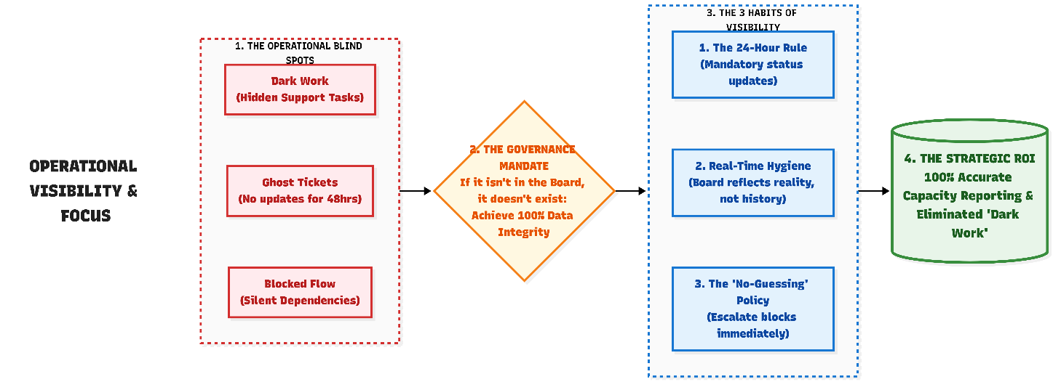
Our governance approach at this stage is not about managers staring at complex dashboards to audit output. It is about the team looking at the board together to see where the system is failing them and where they need leadership's support to clear blockers.

- The Board is the Dashboard (Focused Visibility)
To prevent measurement fatigue, we will not build massive, separate reporting dashboards. The issue tracker (e.g., Jira) is our real-time information radiator
- Governing Flow (The Tension Pair): When looking at the board, we will always view our metrics as a pair. If we see our Cycle Time (speed) getting faster, but our First-Pass Yield / FPY (quality) is dropping because of rework, the board is telling us we are rushing.
- Governing Capacity (The Maintenance Tax): We don't just look at how fast tickets move; we look at the logged effort. If the board shows 40% of our actual logged hours this sprint went to unplanned noise and environment troubleshooting, leadership immediately knows feature delivery is at risk through no fault of the team.

- Shifting from Status to Support (The Cadence)
We are replacing traditional, anxiety-inducing status meetings with a lightweight rhythm designed entirely to protect your focus and capacity.
- Daily (Immediate Unblocking): We will transition our daily stand-up to a rapid, 15-minute "Flow Check". The focus is exclusively: "Are you blocked by unclear requirements, a delayed PR review, or a cross-geography dependency?". You can utilize a targeted 'closed-question' format in Appendix 9.2: The Daily Closed-Question Huddle Script
- Weekly (Habit Building): We will eliminate synchronous weekly status meetings. Instead, the Scrum Master will share a simple, asynchronous summary of the board's health. This includes flagging tickets stuck "In Review" and summarizing the total effort currently burning on unplanned work.

- The Data-Backed, Blameless Retrospective
We will eliminate "gut feeling" retrospectives. When we gather at the end of a sprint, we will use the actual data from our board— like wait times, defect logs, and the explicit effort (hours/days) consumed by the "Maintenance Tax."
- Crucially, we use this effort data as a shield. If feature delivery was slower than expected, the Scrum Master does not question the developers' work ethic; they point to the logged effort data to prove the team was buried in ad-hoc stakeholder requests, and they take an action item to push back on that scope creep for the next sprint.

Analyze Outcomes & Adjust: The Blameless Diagnosis
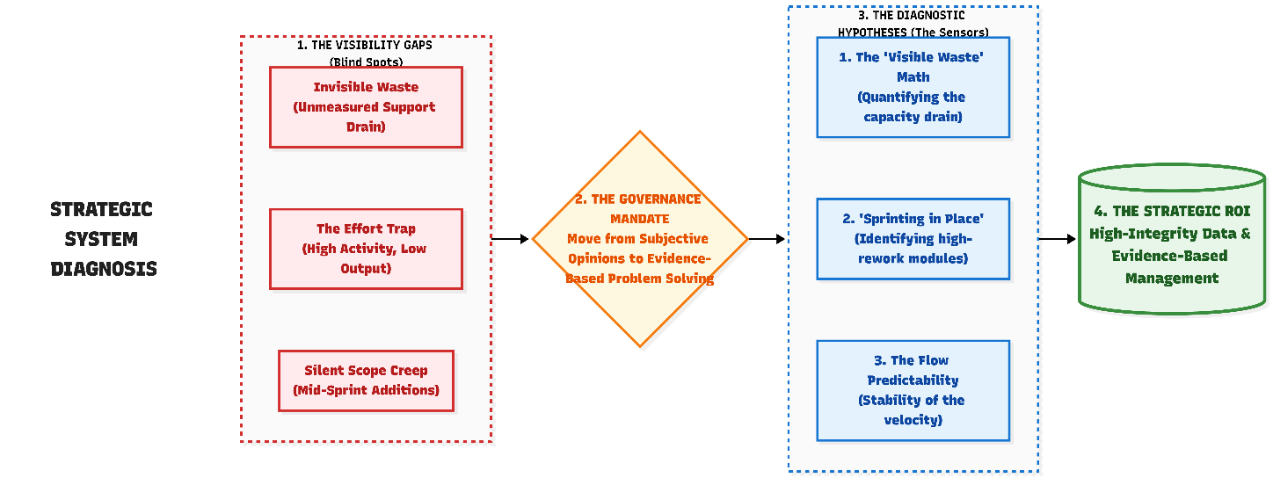
Engineering Leads and Scrum Masters will use a three-step approach to bridge the gap between what the board shows and how the team works. Our culture dictates a strict rule for this phase: metrics are sensors, not scorecards. The goal of troubleshooting is not to find out who is "slow," but to identify exactly where the system is failing the team so leadership can step in and remove the friction.
Step 1 & 2: Spot the Traffic Jam & Isolate the Bottleneck
Before jumping to conclusions or changing a process, we review our simple board metrics to identify obvious patterns of friction, map the journey of that ticket, and isolate where it got stuck.
Use this rapid diagnostic matrix to guide the conversation:
The Symptom  (What the Board Shows) | The Likely Bottleneck  (Where to Look) | The Question to Ask the Team
Cycle Time Slows Down: Coding is fast, but delivery takes days. Or the "Everything is In Progress" Trap. | The "Wait" & Context Switching: Tickets are sitting idle waiting for PR reviews, cross-geo answers, or developers are juggling too many tasks. | "Are PRs sitting unreviewed, are we blocked by cross-geo dependencies, or are we picking up new work instead of swarming to finish active tickets?"
The "Boomerang" Ticket: First-Pass Yield (FPY) drops as work bounces back from QA.. | The Ambiguity / Handoff: Requirements were unclear, or local testing practices are being skipped to meet artificial deadlines. | "Did we lack adequate context before coding started, or did we skip attaching the 'Proof of Local Test' before handing off to QA?"
The "Invisible Fire": Sudden spike in Unplanned Work and Maintenance. | The Capacity Drain: Technical debt, environment outages, and ad-hoc stakeholder requests are consuming the sprint. | "Is this a one-off escalation, or does our logged effort data prove we are bleeding capacity to the 'Maintenance Tax'?"

Step 3: Try a Small Fix (The Adjustment Backlog)
We do not implement sweeping, permanent process overhauls based on a single bottleneck. Instead, we agree as a team to try one or two small, testable adjustments for the next sprint.
- Instead of saying "we need to code faster,"
  - we try a fix: For the next two weeks, let's agree to limit our active 'In Progress' tickets to two per developer to see if finishing tasks sooner improves our Cycle Time
  - we try a fix: For the next two weeks, let’s agree to enforce our rule that no single ticket represents more than 3 to 5 days of effort, our overall Cycle Time will immediately stabilize because smaller tickets are inherently faster to test and flow through the board."
- Instead of saying "we need fewer bugs or need to improve quality,"
  - We try a fix: "For the next sprint, let's agree that before any ticket is moved to 'Ready for QA', the developer must attach a quick screenshot or log file of their successful local smoke test to the ticket."
- The "Capacity Shield" Hypothesis (Maintenance Tax vs. Delivery Limits): "If our explicit 'Maintenance Tax' (captured in the Sprint Bucket) exceeds 20% of our total logged capacity, our ability to deliver planned features will inevitably stall. By visualizing this capacity bleed , we definitively prove to the business that slower delivery is a mathematical reality caused by unplanned noise , not a lack of engineering speed. Validating this hypothesis gives the Scrum Master the explicit data required to execute the 'Capacity Pushback' rule (Section 3.5) in the next sprint."

Learn & Adapt: Small Steps to Better Flow
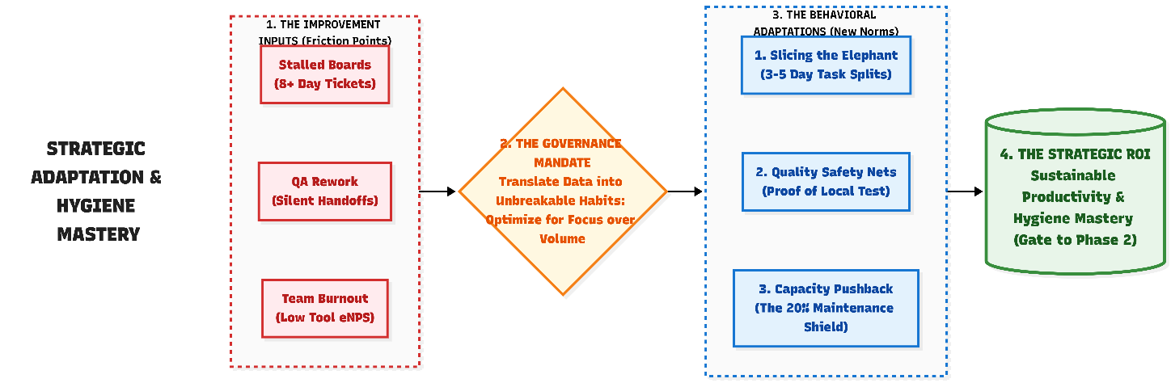
The final phase of our cycle ensures that the friction we spotted on our boards actually leads to a better working environment. At this foundational stage (Phase 1), we are not making sweeping architectural changes; we are just building the muscle of continuous improvement.

- Keeping Flow Simple (Focus over Volume)
  - Finish-to-Start (WIP Limits): We will optimize our days by focusing on finishing work rather than just starting it. Finishing one feature completely is always more valuable than having three features 80% done.
  - "Slicing the Elephant" (Ticket Right-Sizing): If our Cycle Time data shows that tickets are consistently taking 8+ days and stalling the board, we will adapt by actively learning how to break large user stories down into smaller, testable 3-to-5 day chunks during sprint planning.
  - The "30-Minute Struggle" Rule: To keep work moving, we will encourage a simple team habit: if an engineer is technically stuck on a piece of logic or environment issue for more than 30 minutes, they stop spinning their wheels silently and raise a flag on the board or in the team channel so a Tech Lead can swarm and assist.
- Building a Safety Net (Practical Quality)
  - A Simple Definition of Done: Quality at this stage isn't about rigid compliance; it is about preventing the frustrating rework that slows us down. We will start using a basic "Done" checklist to ensure we aren't pushing code that will just bounce back as a bug tomorrow. You can utilize a the simple checklist in Appendix 9.3: The "Definition of Done" (DoD) Checklist
  - The "Proof of Local Test" Handoff: To protect First-Pass Yield (FPY) and respect QA's time, developers stop silently dragging tickets to "Ready for QA." Instead, we make it a habit for the developer to attach a quick screenshot, log file, or screen recording proving their local smoke test passed the basic acceptance criteria. This ensures QA isn't wasting time rejecting tickets for obvious, immediate failures, while preserving QA's complete independence to execute their comprehensive edge-case testing.

- Protecting Capacity & Sustainable:
  - The Capacity Pushback (The 20% Shield): If the team's "Sprint Bucket" (Maintenance Tax) consumed more than 20% of their total effort in the previous sprint, the Scrum Master adapts by explicitly reducing the feature commitment for the next sprint by that exact margin. We do not plan for 100% feature capacity when the data proves the system requires 20% just to keep the lights on. This is a non-negotiable boundary to protect the team from burnout.
  - The "Availability Ratio" (System-Level Sprint Planning): To protect psychological safety and eliminate administrative waste, we explicitly prohibit the use of individual capacity planning spreadsheets (e.g., forcing developers to log their daily available hours in an external tracker). We plan capacity at the system level, not the individual level.
    - The Single Source of Truth: Planned leave is logged exclusively in the official organizational HR portal or team calendar. Developers are not required to duplicate this data into sprint planning sheets.
    - The Availability Math: Prior to Sprint Planning, the Scrum Master calculates the aggregate "Availability Ratio" for the squad. (Example: A 5-person squad over a 10-day sprint has 50 potential working days. If one engineer takes 5 days of planned PTO, the squad's system availability (Availability Ratio ) is 90%).
    - Factoring the "Seniority Gap": Headcount is not always 1-to-1. If the absent team member is a primary mentor, who frequently unblocks the squad, the system loses more than just their individual coding hours—it loses the velocity they provide to others via fast PR reviews and architectural guidance. To account for this systemic slowdown, the Scrum Master could apply an additional "Seniority Penalty" (e.g., reducing the Availability Ratio by an extra 5-10%) to mathematically protect the remaining developers from unrealistic expectations while their mentor is away.
    - The Commitment Formula: To generate a safe, data-backed sprint commitment, the Scrum Master applies a strict sequence:
      - Baseline: Identify the historically proven velocity (e.g., 10 tickets).
      - Adjust for Availability: Multiply by the calculated Availability Ratio (e.g., 10 tickets * 90% = 9 tickets).
      - Apply the Capacity Shield: Deduct the established Maintenance Tax / Tech Debt carve-out (e.g., minus 20% = ~7 feature tickets).
  - Listening to the Team: To ensure our push for visibility does not lead to burnout, we actively monitor tool satisfaction and team well-being. If the board says we are moving fast, but the team feels exhausted or frustrated with their environments, the process is failing and needs an adjustment.

Bringing It All Together: A Day in the Life
The comparison below illustrates how a typical day shifts from a fragmented, subjective experience to one focused on transparent, supported flow:
Time (IST) | The "Before" State (Subjective & Fragmented) | The "Phase 1" State (Making Work Visible)
09:00 - 09:30 | The Status Audit: Checking emails, followed by a 30-minute "Storytelling" stand-up where everyone justifies what they did yesterday. | The Flow Check: A rapid 15-minute huddle focused purely on unblocking. The discussion is simply: "Are the requirements clear?" or "I need a PR review to proceed."
09:30 - 13:00 | The "Quick Favor" Trap: Answering Slack pings and doing ad-hoc work that never makes it to the board, draining capacity invisibly. | Visualizing the Noise: When an urgent request comes in, the engineer logs it as an "Unplanned Work" ticket and actively captures the effort (hours spent). This proves exactly how much capacity was drained by the "Maintenance Tax.".
14:00 - 16:00 | Context Switching: Jumping between half-finished features to show "progress" on multiple fronts. | Single-Task Focus: Working on one primary ticket under strict WIP limits. If stalled by a technical issue for more than 30 minutes, the engineer stops silently spinning their wheels and flags it on the board instead of picking up a fourth ticket.
16:00 - 17:30 | The Rush to "Done": Pushing code through quickly to satisfy a velocity metric or status report, inevitably causing defects later. | Quality Over Speed: The engineer takes extra time to self-test and explicitly attaches their "Proof of Local Test" (a screenshot or log) to the ticket before moving it to QA. They are praised for championing First-Pass Yield (FPY) and doing it right the first time
17:30 - 18:00 | Status Anxiety: Worrying about how to explain a slow day. | Ambient Reality: The engineer logs off without having to worry about a subjective end-of-day status report. Because they maintained real-time discipline (updating ticket statuses and logging effort as they worked), the board already accurately reflects the team's reality.

⚠️ The Gate to Phase 2 (Hygiene Mastery): The squad earns the right to progress to Phase 2 (and begin optimizing their flow) only when baseline visibility is achieved. Specifically: 100% of work is consistently tracked on the board, the "Maintenance Tax" is accurately tagged, and the team's Tension Pair yields stable, reliable baseline data for at least three consecutive sprints.

Phase 2: Walk (Capacity Protection & Async. Flow)

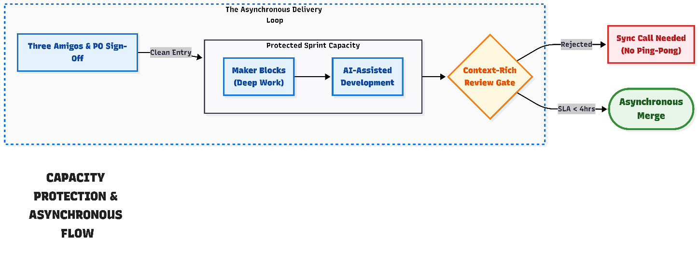

The Goal: Transitioning from basic visibility to tactical alignment, disciplined asynchronous execution, proactive quality assurance, and accountable, AI-assisted knowledge sharing.
The Baseline Assumption: All visibility and hygiene habits established in Phase 1 (e.g., "No Ticket, No Work", effort logging, the 30-minute blocker rule) are permanent Standing Orders. In Phase 2, our 5-step rhythm does not replace those habits; it upgrades them to optimize flow and actively eliminate internal queues.
The J-Curve Reality (Leadership Warning): As teams adopt strict Pull Request gates and explicitly ban "ping-pong" rework, friction will temporarily increase. Leadership must expect Throughput to briefly dip and Cycle Time to spike for the first 2–3 sprints. This is the "J-Curve" (things get slightly worse before they get exponentially better) — a necessary transition of building new muscle memory, not a regression.
To master this phase, the squad executes the 5-step operational rhythm with the following advanced upgrades:

Standardize & Quantify (Pre-Sprint)
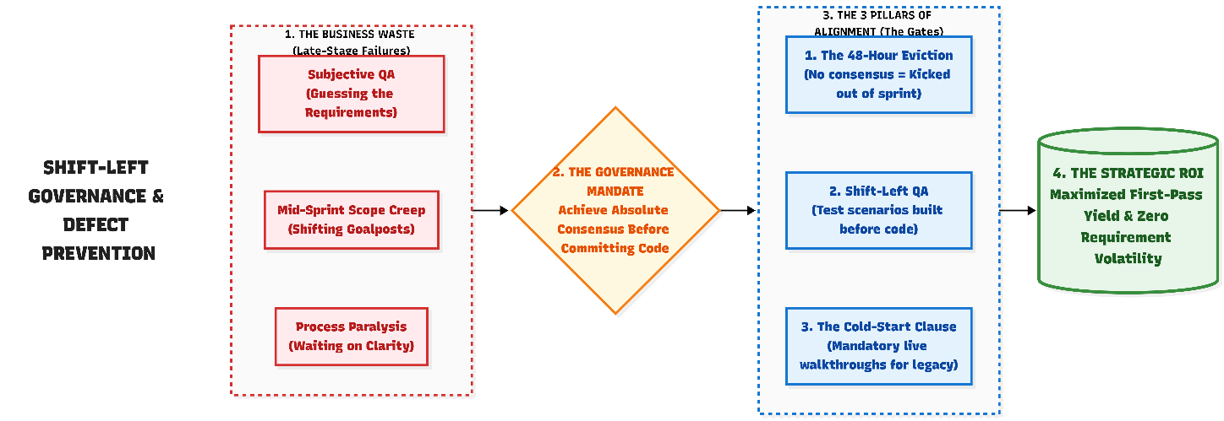

- " Three Amigos" Alignment & Acceptance Criteria: Developers, QA, and Product leads align on a ticket to eliminate ambiguity and finalize testable Acceptance Criteria (AC) before it enters the active sprint. This mandatory domain knowledge transfer ensures the Product Owners explains the business 'Why' so QA can build edge cases independently against the AC. To defend against over-engineering and mid sprint scope creep, the team also explicitly documents what they are not building.

  - The Eviction Rule: To prevent a QA bottleneck, a strict 48-hour SLA is enforced once a ticket enters this phase. Product, Dev, and QA have exactly 48 hours to agree on the scope and attach the finalized QA test scenario. If 48 hours pass without consensus, the ticket is immediately "evicted" from the sprint pipeline and pushed back to the backlog. Developers will not sit idle waiting for unclear requirements

- The "Fast-Track" Exemption & The Cold-Start Clause: We do not paralyze the team with process bloat for minor changes. If a "Minor Enhancement" requires less than 2 days of effort, it bypasses the formal "Three Amigos" meeting.
  - The Default (Known Domain): The PO outlines the requirement, and QA drops the test scenario directly into the ticket asynchronously.
  - The Cold-Start Clause (Unknown Domain): If the assigned QA engineer lacks historical context on the legacy module, they are forbidden from guessing. They must trigger a "Live System Walkthrough"—a strict 15-minute synchronous screen-share where the PO or a veteran Developer demonstrates the current production behavior. QA uses this real-world baseline to establish the new test scenario independently.

- The Shift-Left QA Mandate & Async PO Sign-Off: QA no longer waits for code to be written. QA must generate the exact test scenarios and edge cases before coding begins. Before a developer writes a single line of code, to ensure that everyone is aligned on the right understanding, the Product Owner must provide a lightweight, asynchronous sign-off (e.g., a thumbs-up on the ticket) verifying QA's scenarios match business reality. This ensures QA is testing the actual business reality, not just their own subjective understanding. Once signed off, developers must run these scenarios locally before raising a PR.

Define & Align (The Core Metrics)

- The Focus Shift: We continue tracking our Phase 1 Tension Pair, but we elevate our focus by tracking the quality of our handoffs (e.g., PR reviews) and the measurable impact of our AI tools (proving they accelerate speed without causing sloppy rework).

- New Metrics Added: Throughput, PR Review Latency, Rework Rate, Requirement Volatility, Capacity Variance, and Grooming Efficiency.

Visualize & Govern (Active Sprint)
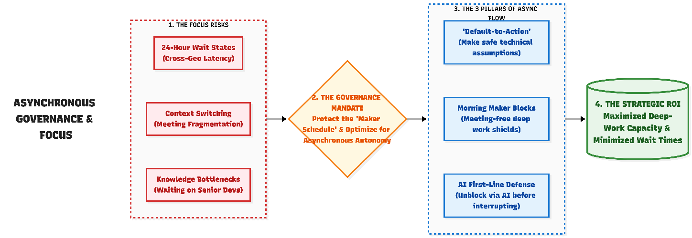

- Visualizing the Wait States & The "Default-to-Action" Protocol: Teams must use explicit wait states on their boards (e.g., "Blocked: Awaiting UK Clarification"). To mitigate 24-hour cycle delays across time zones, developers must rigorously batch their clarifications for the afternoon overlap window.

  - The "Default-to-Action" vs. "The Hard Stop": If the India team submits a blocker during the overlap window and receives no response, the Tech Lead must assess the risk before acting:
    - Reversible Technical Assumptions: If the blocker is a minor technical detail (e.g., an API payload format or UI state), the Tech Lead is empowered to make a "Documented Assumption" on the ticket and proceed. The cost of minor technical rework tomorrow is cheaper than the squad sitting idle.

    - The Hard Stop (Domain/Business Logic): If the blocker involves core business logic, compliance, or unknown domain rules, developers are strictly forbidden from guessing. They must leave the ticket in 'Blocked'. The resulting Cycle Time delay is explicitly logged as a failure of upstream Grooming Efficiency, not engineering speed. We protect quality by refusing to write code based on business-logic guesses.

- The Maker Block: Teams implement meeting-free blocks every morning to fiercely protect deep, uninterrupted coding time.

- AI for Silo-Breaking - The First Line of Defense: For standard local environment errors or deciphering legacy syntax, developers are expected to consult AI tools before interrupting a senior lead's flow. Extreme ownership means attempting to unblock yourself first.

Analyze & Adjust (The Diagnostic Hypotheses)
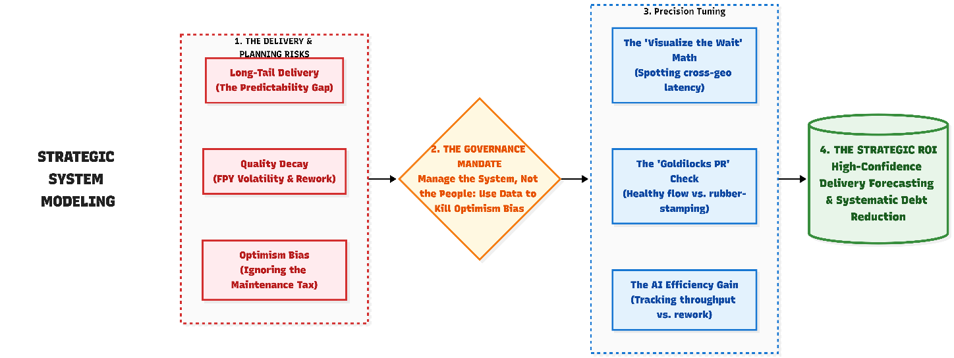
Instead of just looking for stuck tickets, leadership uses the upgraded metrics to test specific operational hypotheses:
- The AI Efficiency Gain Hypothesis (Throughput & Cycle Time): "If our developers utilize AI tools effectively, our overall Cycle Time will organically shrink and our Throughput will rise compared to historical baselines. If this occurs without spiking our Rework Rate, we have definitively proven the ROI of our AI tooling."

- The "Visualize the Wait" Hypothesis (The Latency Math): "By visualizing specific queues on our board, we mathematically capture the exact time-zone latency: $Wait\ Time = T_{Unblocked} - T_{Blocked}$. Batching queries before the afternoon overlap window will demonstrably shrink this aggregated wait time."

- The Execution Discipline Hypothesis (Capacity Variance): "If external 'Maintenance Tax' is low, but Capacity Variance remains negative (missing commitments), the friction is self-inflicted. Tracking this forces the team to confront optimism bias and tighten daily discipline." Tracking this forces the team to confront optimism bias, address self-inflicted bottlenecks like reckless AI reliance, and tighten daily discipline (e.g. neglecting core hours)

- The "Starvation & Scope Creep" Hypotheses: "A drop in Grooming Efficiency proves the team is starved for clear work. A spike in mid-sprint Requirement Volatility proves developers are forced to discard good code due to shifting goalposts."

- The "Shift-Left QA & Domain Prompt" Hypothesis (First-Pass Yield): " "If QA provides validated test data before development begins, developers code directly against the test. However, AI tools will only generate high-value edge cases if QA engineers prompt them with rich, product-specific domain context. A rising First-Pass Yield (FPY) combined with a dropping late-stage Rework Rate mathematically proves our QA team is successfully leveraging their domain mastery to shift quality to the left, rather than just inspecting it at the end."

- The "Goldilocks PR" Hypothesis (Healthy vs. Unhealthy Latency): "PR Review Latency has two distinct failure modes. Unhealthy-Low indicates 'rubber-stamping' and trapped knowledge. Unhealthy-High indicates blocked flow. A 'Healthy' latency (e.g., 2–4 hours) combined with a low Rework Rate proves we are balancing active mentorship with continuous flow."

- The "Context-Rich PR" Hypothesis (Manual & AI-Assisted): "Mandating documented PRs (whether written manually or drafted by AI) directly drives down PR Review Latency and Rework Rate by reducing the reviewer's cognitive load."

- The "Upskilling Progression" Hypothesis (Cross-Shore Mentorship ROI): "If true Continuous Upskilling is occurring, our overall Cycle Time will drop while the percentage of PRs requiring 'blocking' architectural corrections from Tech Leads also steadily declines. If Cycle Time is fast but Tech Lead rejection rates remain high, we are relying on senior reviewers as a crutch rather than building independent architectural mastery across the global squads."

- The "Hidden Ping-Pong" Hypothesis (Sloppy Code & Blind AI): "If our FPY is high but internal Rework Rate is climbing, developers are using peer review as a safety net—either for sloppy manual work or blindly copy-pasted AI code. High rework proves the team is playing 'ping-pong' with incomplete code."

- The "Fast-Track Abuse" Hypothesis (Filtered Throughput vs. FPY): "The Fast-Track exemption is designed for speed. However, if our board data shows that the Throughput of tickets tagged as 'Minor Enhancements' is spiking, but the First-Pass Yield (FPY) on those specific tickets is dropping, the team is misusing the tag to bypass necessary grooming. High rework on allegedly 'small' tickets proves the team is guessing, and the Scrum Master must reinstate strict 'Three Amigos' alignment for those items."

Learn & Adapt (Code Review & Handoff)
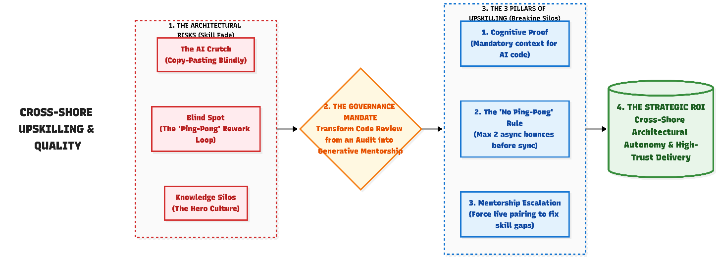
⚠️ While the Scrum Master facilitates the Active Sprint, the Tech Lead or Engineering Manager is the strict and sole enforcer of these Code Review habits.
- Micro-Batching & SLA: Developers stop hoarding large branches. They must raise small, incremental PRs that a peer can comfortably review within 15 minutes. Reviewers commit to a strict internal SLA (e.g., reviewing within 4 hours) to prevent flow stagnation.

- The Context-Rich PR Gate - Hybrid Approach: A developer cannot open a PR with a blank description. For small, straightforward PRs, the developer writes a concise manual summary. For complex changes, developers are encouraged to use AI to draft the summary—but the human author remains strictly accountable for its accuracy. If context is missing, the PR is rejected unread.

- Constructive Mentorship via "Conventional Comments: Tech Leads must use code reviews to actively cross-pollinate architectural knowledge. To make feedback clear and actionable, reviewers prefix their comments with standard labels like blocking: (must fix for safety), suggestion: (a better architectural approach), or nitpick: (a formatting preference)..

- The "No Ping-Pong" Rule: If a PR bounces with comments more than twice, asynchronous review immediately stops. The two engineers must jump on a 10-minute synchronous call to resolve the issue and break the rework loop.

- The Mentorship Escalation (Fixing the Brain Drain): If a developer's PRs consistently require major architectural corrections from senior Tech Leads (triggering the Upskilling Progression Hypothesis), asynchronous review is temporarily suspended for that developer. The adaptation is mandatory synchronous pair-programming. The Tech Lead and Developer must co-create the next feature live, ensuring true knowledge transfer occurs rather than just silent code correction

- The "Leave a Trace" Cold-Start Rule: When a QA engineer triggers a 'Cold-Start' walkthrough for an undocumented legacy module, that knowledge cannot be lost when the sprint ends. The QA engineer is mandated to document the baseline 'happy path' they just learned—either as a permanent, lightweight wiki entry or by coding it into an automated regression test. Once a module has had a Cold-Start walkthrough, it becomes formally documented territory.

- The Dual-Track Onboarding Protocol (Measuring Time-to-Productivity): A new engineer’s "Time-to-Productivity" cannot be measured with a single organizational metric, as it heavily depends on the historical state of the codebase they inherit. To ensure fair measurement, protect morale, and drive systemic improvement, Tech Leads must assign new hires to one of two onboarding tracks during their first 60 days:

  - Track A: The "Greenfield" Track (For documented, modern modules)
    - The Expectation: The developer uses existing Architectural Decision Records (ADRs), Google Code Assist (GCA), and documentation to onboard themselves asynchronously.
    - The Metric: "Time to 10th PR." We measure how many days it takes them to successfully merge 10 pull requests.
    - The Accountability: If this metric is high (slow), it mathematically proves to leadership that the existing architecture is too complex or the documentation is secretly flawed, requiring an immediate capacity carve-out for technical debt.

  - Track B: The "Scout" Track (For undocumented, legacy modules)
    - The Expectation: The developer is explicitly forbidden from struggling in silence. They must trigger the "Leave a Trace" protocol, utilizing mandatory 15-minute synchronous walkthroughs with veteran engineers to understand the system.
    - The Metric: "Knowledge Captured." We measure productivity not by code volume, but by how many undocumented legacy flows the new hire successfully converts into formal documentation or automated baseline tests.
    - The Accountability: This forces mentorship over hero culture. The new hire acts as a "Scout," systemically eliminating tribal knowledge and leaving the legacy codebase better than they found it.

⚠️The Gate to Phase 3 (Metric Stability & Habit Mastery): The squad earns Phase 3 autonomy only when these disciplines become unbreakable norms. . The team must consistently demonstrate extreme ownership in retrospectives, Specifically: Capacity Variance hovers near zero, cross-geography wait times are minimized, a rising FPY proves QA is engaged early, an increasing Throughput combined with a low Rework Rate proves AI is acting as an accelerator, and Tech Leads fully enforce the PR gate

Phase 3: Run (Strategic Automation & Architectural Health)
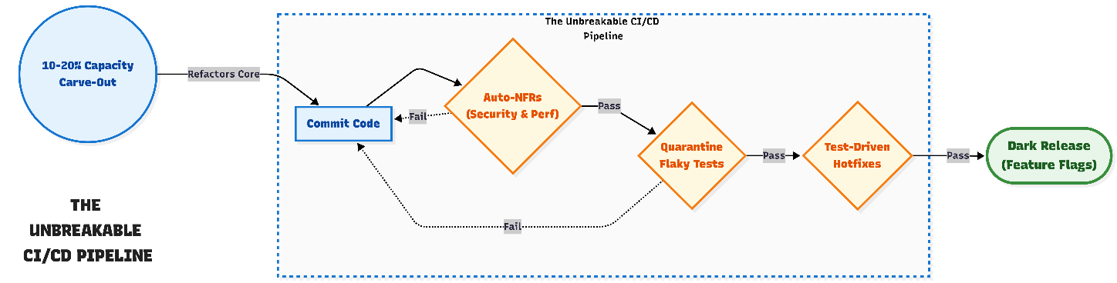
The Goal: Transition from manual discipline to automated safety nets, actively partner with the business to drive product value, and ensure high-speed delivery without falling victim to the Automation Paradox or alert fatigue.
The Baseline Assumption: All Phase 2 habits (Maker Blocks, strict PR gates, QA shift-left) are permanent Standing Orders. Phase 3 upgrades focus on architectural health, pipeline integrity, and reducing deployment anxiety.

Standardize & Quantify (Pre-Sprint)
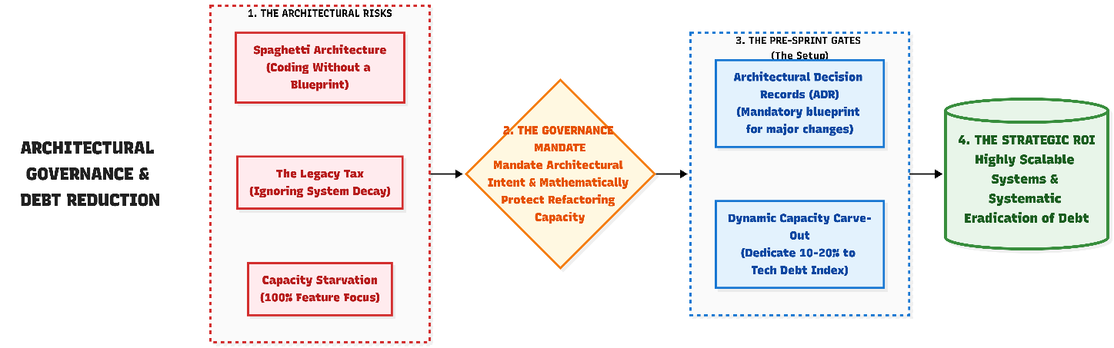

- Architectural Grooming Gates: Senior architects are mandated to be involved during backlog grooming. To prevent rework and ensure scalable design, no major feature—whether integrating a new API or building on legacy code—enters a sprint without a lightweight, documented Architectural Decision Record (ADR). This explicitly defines the architectural approach, trade-offs, and system interactions before coding begins.

- The Dynamic Capacity Carve-Out: 10% - 20%: Mature squads formally negotiate a dynamic capacity carve-out of 10% to 20% during sprint planning. This is dictated by the Technical Debt Index and Change Failure Rate. If the pipeline is brittle, the Scrum Master is authorized to push the carve-out to 20% to stabilize the architecture without requiring executive approval. Any architectural action items generated from Blameless RCAs (Root Cause Analyses) following a production incident are automatically funded through this capacity carve-out.

Define & Align (The Core Metrics)

- The Focus Shift: We add macro-level health metrics to predict long-term stability and predictability: Change Failure Rate (CFR), Escaped Defects, Technical Debt Index, Plan Variance, and CI/CD Wait Time. (Note: We continue to monitor Phase 2's Throughput, but now look for extreme volatility in it).

Visualize & Govern (Active Sprint)
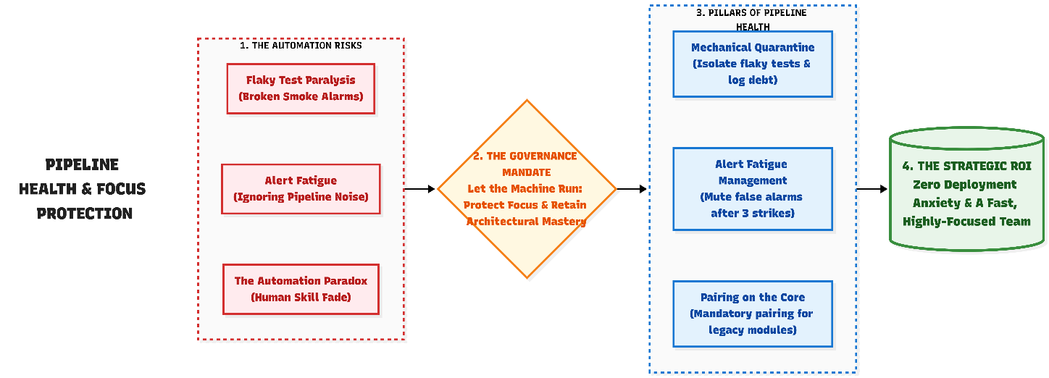

- The Mechanical Quarantine Protocol: Teams have zero tolerance for "flaky" automated tests. Developers are strictly forbidden from hitting "Re-run until green". If a test is flaky, the team executes a mechanical quarantine: they tag the test as @Ignored or @Quarantined so it stops blocking the pipeline, and immediately log a high-priority "Maintenance Tax" ticket to fix it. The pipeline stays fast, but the debt is legally tracked.

- Pairing on the Core - Preventing Skill Fade: To combat the loss of system knowledge caused by high automation (the Automation Paradox), developers utilize their protected Maker Blocks to periodically pair program on complex legacy modules or high-risk changes. This acts as real-time code review and ensures the human team never loses the ability to manually troubleshoot the system.

- Alert Fatigue Management: High automation often leads to noisy Slack channels. The team adopts a strict rule: If an automated alert fires three times in a week and requires no human action, it is classified as "noise." The team is empowered to delete, mute, or retune the alert to protect their focus

Analyze & Adjust (The Diagnostic Hypotheses)
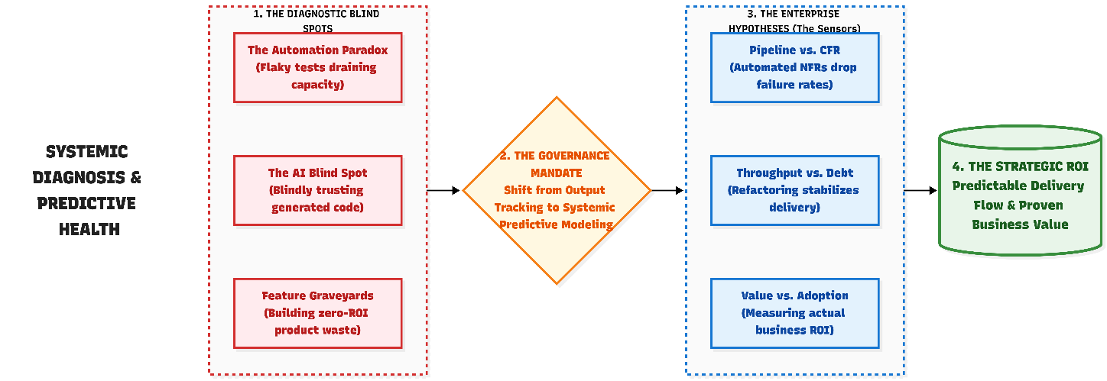

- The "Automation Paradox" Hypothesis (Flaky Tests vs. CI/CD Wait Time): "Automation is meant to speed us up. If our automated test suite grows, but our CI/CD Wait Time spikes and Developer eNPS drops, we are experiencing the automation paradox—maintaining brittle, 'flaky' tests is draining our capacity. Quarantining unstable tests restores trust and speed."

- The "Legacy Tax" Hypothesis (Throughput Volatility vs. Tech Debt Index): "If we continuously build new features on top of a brittle legacy core, our Throughput will become highly erratic and our Plan Variance will spike (missing sprint commitments). Utilizing our Dynamic Capacity Carve-Out to refactor legacy components permanently stabilizes our delivery rate."

- The "Unbreakable Pipeline" Hypothesis (CFR vs. Batch Size): "If Non-Functional Requirements (NFRs) like security and performance are checked manually at the end of a sprint, release batches become large and risky. By embedding NFRs as automated code gates in the CI/CD pipeline, our Change Failure Rate (CFR) will drop, enabling safer, zero-touch deployments."

- The "AI Autopilot" Hypothesis (CFR & Escaped Defects): " As AI tools generate more boilerplate code, our Cycle Time will naturally drop. However, if our Change Failure Rate (CFR) or Escaped Defects rise alongside this speed increase, developers are blindly trusting AI without understanding the generated logic. Tracking this ensures strict 'Human-in-the-Loop' accountability."

- The "Business Value" Hypothesis (Feature Adoption vs. Escaped Defects): "If Engineering successfully delivers a feature with zero Escaped Defects and a fast Cycle Time, but the Feature Adoption Rate remains under 10% after 30 days, the feature is formally classified as 'Product Waste.' Tracking this ensures Engineering capacity is not burned building a 'feature graveyard.' It holds the Product organization equally accountable for the actual ROI of the requirements they push into the pipeline."

- The "Gold-Plating" Hypothesis (Ticket-to-Feature Ratio vs. Adoption): "If a feature requires a massively inflated Ticket-to-Feature ratio (e.g., >15 tickets per feature) but ultimately yields a low Feature Adoption Rate, the system is suffering from 'Gold-Plating' (over-engineering) . By visualizing the raw volume of tickets consumed by a single feature, we mathematically prove to Product leadership that we are over-investing in complex solutions before proving the baseline market demand."

Learn & Adapt (Deployment & Accountability)
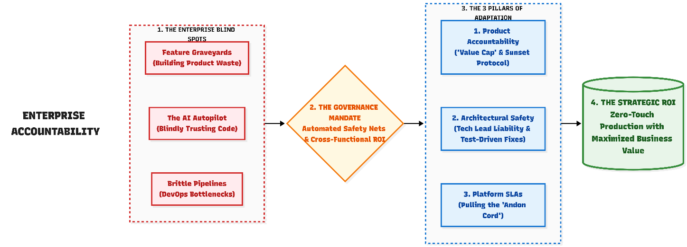
- The "Cognitive Proof" Code Review (Tech Lead Liability): As AI tools generate more logic, the PR Review becomes critical. If a PR contains significant AI-generated logic, the author must proactively leave a PR comment explaining the architectural reasoning behind it.

  - Tech Lead Accountability: If this proof is missing, or if the developer uses a generic, copy-pasted explanation, the Tech Lead must instantly reject the PR. If a Tech Lead approves a PR with a generic "rubber stamp" explanation, that Tech Lead assumes full architectural liability for that AI code. If that code causes an Escaped Defect in production, the Tech Lead is held accountable during the retrospective.

- Decoupling Deployment from Release: To completely remove deployment anxiety, teams implement Feature Flags. Code is continuously merged and deployed to production, but it remains "dark" (hidden from users) until the business is ready to turn it on. This separates technical deployment from the business release, dropping stress levels to zero.

- The Escaped Defect & RCA Protocol (Closing the Feedback Loop): When an Escaped Defect occurs (a Sev-1/Sev-2 incident or a major bug reaches production), the team does not just push a manual code fix. To ensure the system learns from the failure, we execute a two-step blameless resolution:

  - The Test-Driven Hotfix (Developer): The developer is mandated to submit the hotfix alongside a new automated test that explicitly replicates the bug. The PR cannot be approved until the new test proves the vulnerability is sealed.
  - The Blameless RCA (Tech Lead): Before the sprint ends, the Tech Lead must conduct a blameless Root Cause Analysis (RCA) with the squad. The output of this RCA is not a static document; it must be converted into a tangible "Technical Debt" ticket representing the architectural fix needed to prevent it from happening again. This RCA ticket is immediately placed into the backlog to be funded by the squad's Phase 3 Capacity Carve-Out.

- Embedded Non-Functional Requirements / NFRs: Security, compliance, and performance checks are no longer an afterthought checked by a human at the end of a sprint. They are automated directly into the pipeline and embedded into the Definition of Done (DoD). If code violates an NFR, the pipeline automatically rejects the build.

- Pulling the "Andon Cord" (Pipeline Defense): If the CI/CD Pipeline Execution Time routinely violates the 10-minute Platform SLA, developers are experiencing severe flow disruption. The team is authorized to "pull the Andon Cord" (stop the line). The Scrum Master halts new feature work, and the squad redirects their capacity to assist the Platform team in fixing or decoupling the brittle pipeline tests before any new code is merged.

- The "Value Cap" (Scope Freeze): If an active Epic surpasses the baseline Ticket-to-Feature ratio (e.g., hitting 15+ tickets) while still in development, the Scrum Master triggers a mandatory Scope Freeze. Engineering will not accept any further tickets for this feature until the Product Owner publicly re-justifies the business case and strips the remaining requirements down to the absolute Minimum Viable Product (MVP). We protect capacity by refusing to over-engineer unproven features.

- The Sunset Protocol (Pruning Product Waste): If a feature fails the "Business Value" Hypothesis (under 10% adoption after 30 days), it is classified as waste. Engineering does not simply ignore it; leaving dead code in production increases our "Legacy Tax." The adaptation is the Sunset Protocol: the team creates a mandated tech-debt ticket to actively remove the Feature Flag and delete the orphaned code, keeping the core system lean and maintainable.

⚠️The Benchmark for Excellence (The Gate to Mastery): The squad has reached operational mastery when these behaviors are self-sustaining. The team treats their deployment pipelines with the same respect as their production code, uses Feature Flags to deploy without fear, and proactively adjusts their capacity carve-out to systematically eliminate technical debt without management intervention.

The Engineering Automation & Platform Roadmap
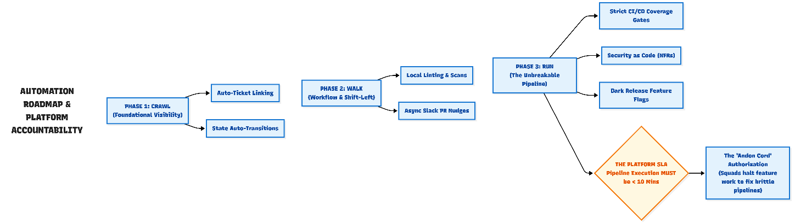
To ensure our push for visibility and quality does not create an administrative burden for the developers, our tooling and pipeline automation should mature alongside our team habits. We should progressively implement automation to eliminate manual tracking, enforce quality gates without human nagging, and create an unbreakable deployment safety net.
Maturity Level & Goal | Focus Area | Key Pipeline & Tooling Automations
Phase 1: Crawl  (Foundational Visibility)  Goal: Eliminate manual data entry and connect our code to our board. | Do not have developers spend time manually updating statuses or compiling metrics spreadsheets. | 1. Ticket-to-Branch Linkage: Branch names and commits must include the issue ticket number (e.g., JIRA-123) to auto-link code to the board.  2. State Auto-Transitions: Opening a PR auto-moves the ticket to "In Review"; merging moves it to "Done".  3. Automated Metric Extraction: Issue trackers auto-generate the "Tension Pair" dashboards (Cycle Time & FPY).
Phase 2: Walk  (Workflow & Shift-Left)  Goal: Automate the "nagging" out of the process and catch errors before human review. | Automate predictable friction points once the team is using Maker Blocks and cross-role pairing. | 1. Local Shift-Left: Automated linting, formatting, and secret-scanning run locally upon commit, preventing obvious errors.  2. Asynchronous Nudges: Slack/Teams integrations auto-tag reviewers if a PR sits idle for 24 hours, protecting Cycle Time.  3. Staging Environments: Merging code triggers automated deployments to temporary staging areas for immediate QA testing.
Phase 3: Run  (The Unbreakable Pipeline)  Goal: Remove human subjectivity from release readiness and establish a zero-touch path to production. | Mature squads rely on the CI/CD pipeline, not manual checklists, as the ultimate judge of quality and security. | 1. Strict Coverage Gates: CI/CD automatically rejects PRs failing agreed-upon automated test coverage thresholds (e.g., 80%).  2. Security as Code (NFRs): Static Application Security Testing (SAST) and Software Composition Analysis (SCA) run on every PR; vulnerabilities automatically fail the build.  3. Continuous Deployment (CD): Validated code is packaged and staged for production with a single click (or zero clicks).

⚠️The Platform SLA (Protecting Developer Flow): Mandating 'Zero-Touch Production' and strict CI/CD coverage gates in Phase 3 transfers a massive dependency onto the DevOps/Platform team. To ensure developers are not penalized for infrastructure delays, the Platform team is held to a strict SLA: CI/CD Pipeline Execution Time must remain under 10 minutes . If pipeline execution consistently exceeds this threshold, squads are authorized to suspend new feature development and redirect their capacity to assist the Platform team in optimizing the pipeline architecture

Leadership Governance: The Pact of Trust
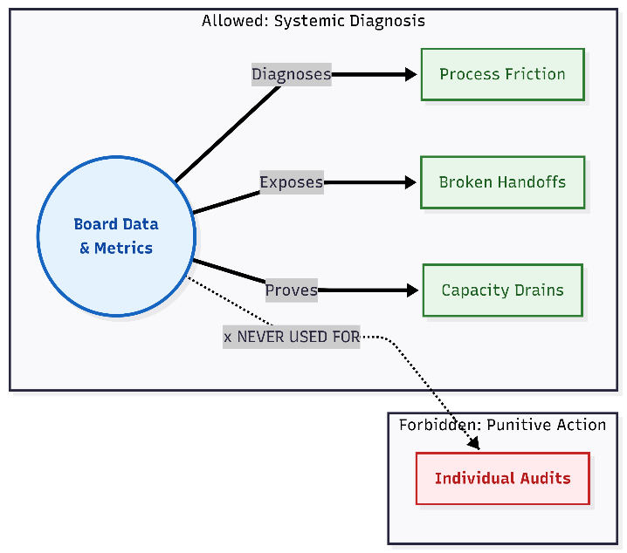
To successfully transition to a culture where work is visible and supported, leadership makes a non-negotiable commitment to psychological safety. We recognize that introducing metrics and tracking can sometimes cause anxiety. Therefore, we are establishing a clear rule: metrics exist solely to improve the system and remove your blockers, never to measure individual output or induce stress.
- Fixing the Process, Not the Person (Systemic Accountability) Metrics will be used strictly to diagnose process friction, tool deficiencies, and bottlenecks. They will never be used for punitive, individual performance reviews.
- Safety in Numbers (Aggregation): To protect individual contributors and foster a safe environment, leadership reviews will not scrutinize individual engineer data. Data will be rigorously aggregated at the squad level to look at overarching team health and flow.
- Quality Over "Point-Keeping": We will actively guard against perverse incentives. We will never reward sheer volume, ticket-closing speed, or "gaming the system" at the expense of software quality and stability.
- A Two-Way Street (Listening to the Team): We will not just collect data on tool satisfaction or team well-being in a vacuum. If the team highlights burnout risks or tool frustrations, leadership commits to connecting these inputs to actionable next steps to continuously improve the developer experience.

Guarding Against Perverse Incentives (Metric Integrity)
While this Pact of Trust protects the team from micromanagement , we must also protect the system from being unintentionally "gamed". Even in a safe environment, the desire to show progress can sometimes lead to optimizing a single metric at the expense of overall health—such as rushing code to improve Cycle Time while sacrificing stability.

- For a complete diagnostic guide on how leadership and Scrum Masters should monitor for these warning signs—including the "Cliff Effect," PR "Rubber Stamping," and Burnout—please refer to Appendix 9.4: Metric Integrity.

Target state
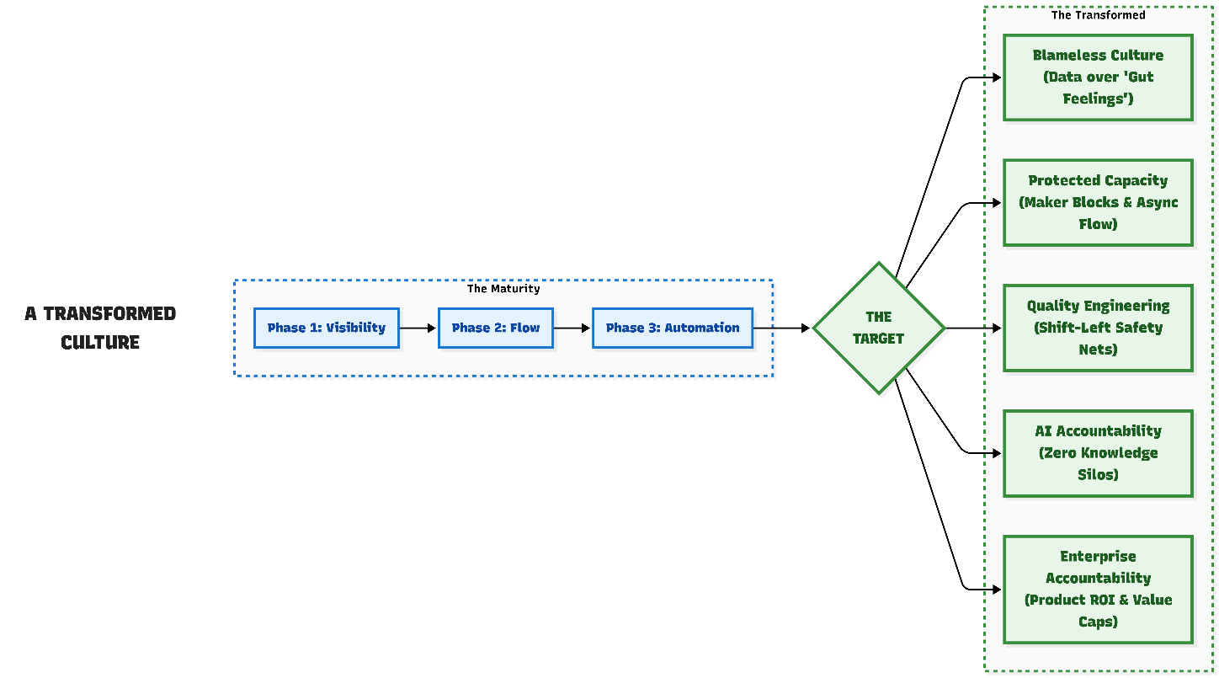
When all three phases of this Engineering Maturity Roadmap are fully implemented, our engineering organization will operate under the following conditions:
- A Visible, Blameless Culture: We no longer rely on subjective status updates or "gut feelings" to explain our workloads. We use aggregated data exclusively to spot bottlenecks, advocate for better tooling, and push back on scope creep, never for individual tracking.

- Asynchronous Flow & Protected Capacity: We have significantly reduced meeting fatigue and internal queues. We protect our deep work through dedicated "Maker Blocks," rigorous time-zone batching, and by logging all ad-hoc requests to defend our actual capacity.

- High Psychological Safety: Developers feel completely safe raising their hands when they are stuck, voicing concerns about clunky systems, and asking for help, knowing their well-being is valued equally alongside their technical output.

- From QA to Quality Engineering (QE): QA is no longer treated as a downstream bottleneck or a manual inspection team. By shifting left, utilizing AI for edge-case generation, and governing our CI/CD pipelines, our QA professionals operate as strategic Quality Engineers who build automated safety nets rather than manually chasing defects.

- Everyday Learning & AI Accountability: We no longer rely on knowledge silos. We use everyday workflow moments—like context-rich PR reviews and pair-programming on core legacy modules—to mentor each other, ensuring that human mastery of the system remains intact alongside our AI adoption.

- Enterprise-Wide Accountability: Engineering is no longer a black-box execution team taking orders. Through metrics like the Ticket-to-Feature Ratio and Feature Adoption Rate, we actively hold the Product organization accountable for the business value of their requests, enforcing 'Value Caps' to prevent over-engineering and utilizing the 'Sunset Protocol' to ruthlessly prune dead code

Appendix
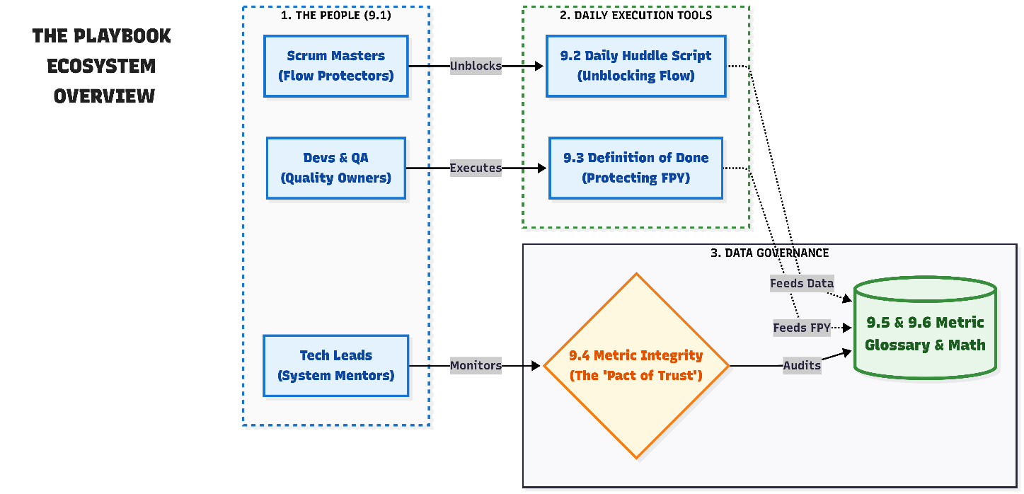

Role Definitions: Partnering for Flow
To successfully move away from subjective status reporting and "invisible work," we are slightly shifting how our roles interact day-to-day. At this stage, our goal is not rigid, end-to-end accountability. Instead, we are establishing how each role helps make the work visible, supports the team in clearing blockers, and builds trust in our new data.
1. Developers
- The Mindset Shift: Shift from "I just write the code" to "I make my work visible, log my effort to protect our capacity, and raise my hand when I'm blocked."
- Phase 1 (Crawl): Keep your active tickets accurately updated on the board so you never have to justify your day in a status meeting. You must log the actual effort (hours/days) you spend on unplanned work or environment troubleshooting so your Scrum Master has the data to defend your time. We pay attention to the Rework Rate to build it right the first time.
- Phase 2 (Walk): Write clear PR descriptions so your peers can review your work without needing a synchronous call. Respect the morning "Maker Blocks," and adhere strictly to the internal PR Review SLA (e.g., 4 hours) to eliminate internal queues.
- Phase 3 (Run): Take absolute cognitive ownership of all AI-generated code. Pair program on legacy modules to prevent human skill fade, and ensure all commits strictly pass the automated Non-Functional Requirement (NFR) pipeline gates.
2. Technical Designers / Architects
- The Mindset Shift: Shift from "creating static diagrams" to "removing ambiguity before coding starts."
- Phase 1 (Crawl): Ensure that before a developer picks up a ticket, the architectural path is clear and the requirements are understood. Help the team break down large, confusing features into smaller, clear tickets. Watch the Design Review Cycle Time.
- Phase 2 (Walk): Lead the "Three Amigos" pre-sprint alignment. Explicitly document the "Out of Scope" boundaries to defend the team against gold-plating and scope creep.
- Phase 3 (Run): Enforce strict Architectural Grooming Gates before sprints begin. Champion the squad's 10% capacity carve-out to systematically eliminate technical debt.
3. Testers / Quality Engineers (QA)
- The Mindset Shift: Shift from "finding bugs at the end" to "partnering with Product and Dev to clarify acceptance criteria early and act as domain experts."
- Phase 1 (Crawl): Get involved while the ticket is still being groomed. Help the developers understand exactly how the feature will be tested so they can build with those scenarios in mind. Testers champion our First-Pass Yield (FPY) metric.
- Phase 2 (Walk): Execute the "Shift-Left Mandate" by providing exact test scenarios before the developer begins coding. To achieve this, QA engineers must actively cultivate deep domain and product knowledge, asking Product Owners 'What happens if...' regarding complex business rules, rather than just technical functions.
- Phase 3 (Run): Transition from manual end-of-sprint inspection to governing the automated CI/CD coverage gates. QA acts as the ultimate domain guardians, ensuring that automated tests reflect the most complex, real-world business scenarios (e.g., UK compliance logic), not just basic code functionality. Enforce the "Quarantine Protocol" to immediately isolate and fix flaky automated tests.
4. Scrum Masters / Agile Delivery Leads
- The Mindset Shift: Shift from "status checker and meeting facilitator" to "flow protector and capacity defender."
- Phase 1 (Crawl): Facilitate the 15-minute daily Flow Check, ensuring it stays focused on unblocking work rather than storytelling. Actively ensure all "quick favors" and urgent bugs are logged on the board so the team's true workload is visible. Use the team's logged effort on unplanned work (The Maintenance Tax) to explicitly push back on scope creep and negotiate realistic sprint commitments.
- Phase 2 (Walk): Scrum Masters monitor Cycle Time and Capacity Health—not to push the team to work faster, but to spot tickets that are stuck and explicitly protect the team from external interruptions. Enforce time-zone batching to prevent cross-geography delays.
- Phase 3 (Run): Actively advocate for Developer eNPS (team well-being) amidst high automation. Assist the Tech Leads in negotiating the formal 10% technical health capacity carve-out with product leadership.
5. Tech Leads / Agile delivery lead(s) / Architects
- The Mindset Shift: Shift from "sole decision-maker" to "team mentor and system troubleshooter."
- Phase 1 (Crawl): Help the team resolve complex blockers that are stalling the board. Guide the team in selecting small, safe process adjustments for the next sprint. Leads keep an eye on technical debt to ensure our new features aren't making the codebase harder to maintain down the line.
- Phase 2 (Walk): Use PR reviews as mentoring moments rather than just passing or failing code. Become the strict enforcer of the "Context-Rich PR Gate" and the "No Ping-Pong" rule for bouncing PRs.
- Phase 3 (Run): Act as the final human safeguard against the Automation Paradox. Instantly reject PRs if developers are blindly trusting AI-generated logic without understanding it, ensuring human mastery of the codebase remains intact.

The Daily Closed-Question Huddle Script
This format ensures the team stops talking to the manager and starts talking to each other about actual value flow. It creates a binary understanding of system health: the work is either flowing smoothly, or it is blocked by an internal queue or a global time-zone delay.
The Focus | The Closed-Question | The Immediate Action
1. Focus & WIP Limits | "Is everyone working on only one active ticket today?" | If No: Note which secondary tickets need to be parked immediately to reduce context switching.
2. The Handoff (Dependencies) | "Does anyone require clarification, approval, or data from the local or global team to keep working tomorrow?" | If Yes: Draft and send a clear, asynchronous request immediately so it is waiting in the respective team's inbox when they log on.
3. Internal Flow (PRs) | "Do we have any Pull Requests that have been sitting unreviewed for more than 24 hours?" | If Yes: Stop and assign a reviewer immediately on the call to prevent work from stalling in internal queues.
4. Quality & Compliance | "For the bugs in progress, do we have a 100% reproducible scenario locally with clear acceptance criteria?" | If No: Stop coding. The developer must go back to triage. Guessing at a fix introduces unacceptable stability risks.
5. Value Delivery | "Are we confident we will move at least one item to 'Done' or 'Ready for Stakeholder Review' by the end of our shift today?" | If No: The team is stuck. The Scrum Master stays on the call with the blocked engineers to map out the exact friction point.
6. Capacity Protection (The Invisible Fire) | "Is anyone currently being pulled into ad-hoc stakeholder requests, or fighting an environment outage that is not currently tracked on the board?" | If Yes: Stop coding. The engineer takes 2 minutes to create an "Unplanned Work" ticket and logs their current effort so the Scrum Master can see the capacity drain and intervene to shield them.

The "Definition of Done" (DoD) Checklist
Our DoD is a lightweight safety net. We are not aiming for 100% automated perfection yet; we are aiming to protect our First-Pass Yield (FPY) by eliminating silly mistakes and the last-minute rush of fixing early bugs. Before moving a ticket to 'Done' or 'Ready for QA', developers must verify the following:
- Code Quality & Shared Context
- [ ] Peer Reviewed: At least one other developer has looked at the code. (Goal: Share knowledge and catch obvious logic errors, not to rigidly gatekeep).
- [ ] Clean Basics: No hardcoded credentials or API keys are left in the code. Code is readable and follows basic team naming conventions.
- Basic Testing (The "Happy Path")
- [ ] Unit Tests Passed: Automated unit tests cover at least 80% of the new logic.
- [ ] Manual Smoke Test: The developer has personally verified the "happy path" works locally or in a dev environment.
- [ ] No Obvious Regressions: The new code doesn't immediately break the main build or existing baseline tests.
- AI-Assisted Code (Human-in-the-Loop)
- [ ] Cognitive Ownership: If AI was used to generate logic, the developer can fully explain how the code works and how it utilizes resources without relying on the AI.
- [ ] Data Privacy: No proprietary business logic or live production data was used in prompts to external/unapproved LLMs.
- Documentation & Handoff
- [ ] API Specs: If an endpoint was added or changed, the Swagger/OpenAPI documentation is updated.
- [ ] Ticket Updated: The Jira/Azure board ticket is updated with any specific instructions QA might need to test the feature.
- [ ] Comments: Complex logic blocks are explained with "why" comments, not just "what."
- [ ] README/Config: If the change requires a new setup step or environment variable, it is documented.
- Operations & Performance
- [ ] Logging & Monitoring: Error handling is implemented, and critical events are logged for debugging.
- [ ] Performance: The feature does not significantly degrade system latency or resource usage.
- Product Alignment
- [ ] Acceptance Criteria Met: The core requirement listed in the User Story is actually solved.

Metric Integrity: Safeguarding the "Pact of Trust"
To keep our data-driven culture healthy, we must ensure our new visibility doesn't accidentally create perverse incentives. We strictly follow the principle that metrics are for systemic diagnosis, never for punitive individual tracking.
However, when teams feel pressure to show "progress," human nature often leads to optimizing a single metric at the expense of overall health. To prevent this, leadership and Scrum Masters must continuously monitor our data using "Tension Pairs"—never looking at speed without also looking at quality or stability.
- The Primary Check: Speed vs. Quality (Phase 1 Trap)
- The Imbalance: Cycle Time is getting significantly faster, but First-Pass Yield (FPY) is dropping .
- The Diagnosis: The team is rushing to move tickets to 'Done' without proper local testing or peer review, causing the work to bounce back from QA. We are sacrificing stability for the illusion of speed .
- The "Cliff" Effect (Batching Trap)
- The Imbalance: Throughput looks healthy for the sprint, but there is a massive spike in items moved to "Done" on the very last day of a sprint .
- The Diagnosis: This indicates a "mini-waterfall." QA is being bottlenecked until the last minute, and items are being marked "Done" without truly meeting the full Definition of Done (DoD) checklist just to satisfy a completion target .
- The PR Review "Rubber Stamp" (Phase 2 Trap)
- The Imbalance: PR Review Latency drops to near-zero (code is approved almost instantly), but internal Rework Rate is high or bugs are slipping through .
- The Diagnosis: Engineers are "rubber-stamping" PRs to keep the board moving, completely bypassing the "Cognitive Proof" and peer-to-peer mentorship we expect during code reviews.
- The "AI Autopilot" Illusion (Phase 3 Trap)
- The Imbalance: Cycle Time drops dramatically (features are built fast), but Change Failure Rate (CFR) or Escaped Defects suddenly spike.
- The Diagnosis: Developers are relying too heavily on AI to generate boilerplate code and are copy-pasting it without understanding the underlying logic. The AI is making us type faster, but we are deploying broken architecture.
- The "Coverage Theater" Trap (Phase 3 Trap)
- The Imbalance: Automated test coverage hits 100% to pass the strict pipeline gates, but CI/CD Wait Time spikes to 45+ minutes and the Quarantine test list grows daily.
- The Diagnosis: The team is experiencing the Automation Paradox. They are writing brittle, useless tests simply to satisfy the coverage metric, which is now draining capacity to maintain and destroying the developer's daily flow.
- The Burnout Check (Pace vs. People)
- The Imbalance: The board looks fantastic—Cycle Time is low, FPY is high, Throughput is stable—but the Developer eNPS (team pulse) is plummeting .
- The Diagnosis: The productivity gains are built on unsustainable heroics, overtime, and silent burnout, rather than actual systemic flow improvements
- The "Echo Chamber" Trap (False Positive FPY)
- The Imbalance: First-Pass Yield (FPY) is consistently near 100%, but the UAT (User Acceptance Testing) Rejection Rate or Escaped Defects are climbing.
- The Diagnosis: The developers and QA are perfectly aligned, but they are aligned on the wrong understanding of the product. QA is only testing their own flawed assumptions, and the developers are passing those flawed tests. The team needs to enforce strict Product Owner validation of the test scenarios during the "Three Amigos" phase before development begins

Glossary of Metrics
This comprehensive list is strictly for background analysis and systemic troubleshooting at higher maturity levels.

Discovery & Requirement Flow
- Requirement Volatility: Measures the percentage of stories changed or expanded after a sprint has started. (High volatility signals poor grooming) .
- Grooming Efficiency: The ratio of stories successfully moved to "Ready for Dev" versus the number of items "Evicted" back to the backlog due to failing the 48-Hour SLA during the Three Amigos phase.
  - Governance Note: A high Eviction Rate mathematically proves that Product Owners are bringing half-baked requirements to the engineering team. This metric is used to push for better upstream alignment, ensuring developers aren't starved for well-defined work
- Time-to-Value (Total Lead Time): Difference between time stamps from business "Idea" submission to production deployment . (Captures the efficiency of the entire organization, not just engineering)

Design & Architectural Integrity
- Design Review Cycle Time: Average time for a technical design or architectural proposal to be reviewed and approved . (Identifies bottlenecks in the "Shift-Left" phase) .
- Architectural Stewardship Latency: Specifically tracking the PR Review Latency for shared or core repositories. (Ensures stewards are enabling, not blocking, the squads) .
- Technical Debt Index: Remediation effort required for legacy components
  - Formula: (Estimated remediation effort) / (Total development effort) × 100

Delivery Velocity & Flow
- Cycle Time: Difference in time stamps from work item start to completion (‘Done’).
- Throughput: Number of work items completed per time period. Count of items completed in a defined period (Sprint/Month), grouped by complexity.
- Sprint Velocity: Amount of work completed per sprint (measured in story points or work units).
- CI/CD Wait Time (Pipeline Execution Time): Measures the duration of automated feedback loops to prevent the "Automation Paradox." Difference in timestamps from code commit to pipeline completion (Pass/Fail status returned to the developer) Automatically extracted via CI/CD platform webhooks (e.g., GitHub Actions, GitLab CI) to the engineering dashboard. Target SLA is <10 minutes
  - Governance Note: Used exclusively for internal squad capacity planning; not to be compared across different squads.

Quality
- Defect injection rate: Rate of defects introduced during a development phase.
  - Formula: Defects found in later stages / Total changes or features implemented
- Rework rate: Proportion of work redone due to defects or changes
  - Formula: Reworked work items (or Hours) / Total work items (or Total time)
- Test automation coverage: Portion of test cases or code covered by automation
  - Formula: Automated test cases / Total test cases × 100

Stability (High-Compliance Focus)
- Escaped Defects: Defects found in production after release.
  - Formula: Count of defects logged against production versions / Total defects found across all environments.
You can choose to have this calculated per sprint/release and group accordingly
- First-Pass Yield (FPY): Percentage of items that pass testing on the first attempt without rework. (This is our primary measure of QA efficiency, as a high FPY mathematically proves QA is not wasting capacity on testing, rejecting, and re-testing the same sloppy ticket multiple times).
  - Formula: Passed items on first test / Total items tested.
You can choose to have this calculated per sprint/release and group accordingly
- Change Failure Rate (CFR): The percentage of changes that fail after deployment, requiring hotfixes or rollbacks.
  - Formula: (Failed changes / Total Deployments) × 100.
- MTTR (Mean Time to Restore/Repair): Average time to restore service after a failure.
  - Formula: Total downtime across incidents / Number of incidents.

Predictability & Planning
- Plan Variance (Sprint/Release Accuracy): Deviation between planned work and actual delivered work.
  - Formula: (Planned work - Actual delivered) / Planned work × 100.
- Capacity Variance: Deviation from planned versus actual capacity.
  - Formula: Actual logged capacity - Planned capacity (measured as a % or in hours).
- Cycle time Stability: Variability of cycle time
  - Formula: StdDev(Cycle time across items) / Mean(Cycle time) × 100
- PR Review Latency: Reflects Team responsiveness
  - Formula: first review timestamp – pull request creation timestamp
- Maintenance Tax (The Sprint Bucket Ratio): The percentage of total sprint capacity consumed by unplanned noise, ad-hoc support, and environment firefighting.
  - Formula: (Total explicit hours logged to the "Sprint Bucket" / Total available engineering hours in the sprint) * 100.
  - Governance Note: If this metric consistently exceeds 20%, leadership must intervene to shield the team from external scope creep before adding more features to the backlog.

Business & Developer Alignment
- Feature Adoption Rate: Percentage of users adopting a new feature.
  - Formula: Active users of a specific feature / Total active users × 100.
- Ticket-to-Feature Ratio (Feature Investment Cost): The total volume of tickets (Stories, Tasks, and Story Defects) required to deliver a single Epic or Feature to production.
  - Formula: Total tickets executed under a parent Epic / 1 Feature.
  - Governance Note: Used in conjunction with Feature Adoption to weigh the engineering cost of delivery against the actual business reward. An unusually high ratio indicates "Gold-Plating" or extreme scope creep.
- NPS / CSAT / eNPS: Customer and Developer satisfaction metrics.
  - Formula: Net Promoter Score = % Promoters - % Detractors. (Crucial to apply internally as Developer eNPS to measure tool satisfaction and burnout risk).

Project
- Budget variance: Difference between planned and actual budget
  - Formula: Actual spend − Planned budget
- Scope creep percentage: Expansion of project scope over time
  - Formula: (Actual scope − Planned scope) / Planned scope × 100

The Tension Pair in Practice: Calculation Examples
The following examples illustrate exactly how our core Tension Pair metrics are calculated in day-to-day scenarios. Remember our Golden Rule: these calculations rely entirely on disciplined manual tracking. If a ticket isn't moved to "In Progress" when you start, the system cannot see your friction.

Measuring Cycle Time (Flow)
Cycle Time measures the total time a ticket spends actively being worked on or waiting in a queue. We measure the difference in timestamps from the moment you move a ticket to "In Progress" until it reaches "Done".
Example A: Smooth Flow (Individual Calculation). A developer moves a ticket to "In Progress" on Monday at 9:00 AM. They work on it steadily, test it locally, and move it to "Done" on Wednesday at 5:00 PM.
  - The Result: A ~3-Day Cycle Time. This is healthy flow, keeping work bite-sized.
Example B: Beating the Wait State (Technical Default-to-Action). A developer moves a ticket to "In Progress" on Tuesday. They hit an ambiguous technical requirement (e.g., an unspecified data format). With no response from the UK by Wednesday morning, the Tech Lead invokes the "Default-to-Action" protocol, documents a safe technical assumption, and the developer finishes coding by Wednesday afternoon.
  - The Result: A 2-Day Cycle Time.
Why We Measure This: By empowering the squad to make safe, reversible technical assumptions rather than waiting 24 hours, the team retains their momentum.
Example C: he Hard Stop (Domain Knowledge Gap). A developer begins coding on Tuesday but hits an ambiguous UK business-logic rule. They cannot make a safe assumption. They flag it, but due to time-zone delays and a missed overlap window, the UK Product Owner doesn't provide the domain clarification until Thursday. The developer finishes on Friday.
  - The Result: A 4-Day Cycle Time (even though active coding was 2 days).
Why We Measure This: We do not view this 4-day result as the developer being "slow." The board accurately shows that poor upstream grooming and cross-geography handoffs stalled the work. We use this Cycle Time data to justify enforcing the 48-Hour Eviction SLA during the Pre-Sprint phase.
Example D: The Sprint Average (Team-Level Calculation). Over a two-week sprint, the squad completes 5 tickets. The individual cycle times were: 2 days, 3 days, 3 days, 7 days, and 5 days.
  - The Result: An average 4-Day Cycle Time.
Why We Measure This: While the average is 4 days, the team spots the "traffic jam" (the 7-day ticket) during the retrospective. Instead of blaming the developer, the team isolates the bottleneck (e.g., sitting in an internal PR review queue for 48 hours).

Measuring First-Pass Yield / FPY (Quality)
FPY is our primary indicator of process quality. The formula is simply: Passed items on first test / Total items tested.
Example A: The "Shift-Left" Success (High FPY). A developer finishes a feature, completes the Definition of Done (DoD) checklist, and moves the ticket to "Ready for QA". The code passes perfectly on the first try.
  - The Result: 100% FPY (1 passed / 1 tested). The developer prioritized doing it right the first time over rushing.
Example B: The "Boomerang" Ticket (Low FPY). A developer quickly finishes coding a complex logic change on Friday afternoon, skips local testing to save time, and pushes it directly to QA to hit a velocity target. On Monday, the code fails a baseline test, is rejected, and boomerangs back to the "In Progress" column.
  - The Result: 0% FPY (0 passed / 1 tested).

Why We Measure This: Even if the Cycle Time looked fast initially, the system is out of balance. This metric proves that rushing to meet an artificial deadline creates downstream instability, giving leadership the data to push back on unrealistic timelines.
Example C: The Sprint Aggregate (Team-Level Calculation). Over a two-week sprint, the team sends 10 completed tickets to QA. 7 tickets pass flawlessly on the first attempt. 3 tickets bounce back due to bugs or missed criteria.
  - The Result: 70% FPY (7 passed / 10 tested).
Why We Measure This: A 70% FPY isn't inherently a "failing" grade, but it sparks the right conversation during the retrospective. The team uses this 30% rework rate to ask systemic questions: Were the requirements unclear? Did we lack a reproducible scenario locally?

The Future Horizon (Phase 4: Scale & Optimize)
The immediate focus of this strategy is stabilizing throughput and quality (Phases 1-3). However, as deployment velocity increases, the next organizational bottleneck will be cloud infrastructure costs.
Future Roadmap (Target: Q2’27): The FinOps Shift-Left Protocol Once the core Tension Pairs are stabilized, we will introduce Cloud Cost as a tertiary quality metric. This will include mandating automated Time-To-Live (TTL) limits for non-production environments and requiring cost-delta estimates on all infrastructure-modifying Pull Requests.

Analyze & Adjust: The FinOps & Cloud Cost Blind Spot
Transitioning from treating cloud infrastructure as an "infinite resource" to treating financial cost as a strict Non-Functional Requirement (NFR) embedded in the delivery pipeline.

THE FINANCIAL BLIND SPOTS (The Profit Leaks)
- The "Infinite Cloud" Illusion: Developers spinning up high-tier, expensive resources to hit velocity targets without understanding the monthly cost impact.
- Zombie Resources (Idle Waste): Staging environments, test databases, and orphaned infrastructure left running 24/7 because there is no automated cleanup protocol.
- Architectural Over-Provisioning: Solving application performance bottlenecks by throwing expensive compute power at the problem rather than refactoring the underlying code.

THE GOVERNANCE MANDATE
- Treat Cost as Code: Shift from viewing cloud bills as a post-release Finance problem to a strict engineering constraint. Cost efficiency must be mathematically proven before deployment.

THE ENTERPRISE HYPOTHESES (The Sensors)
- The "Zombie Environment" Hypothesis: "If our overall cloud spend spikes while our Sprint Throughput remains stable, we are paying for idle capacity. By mandating automated 'spin-down' scripts for all non-production environments outside of core working hours, we will mathematically eliminate off-hours waste."
- The "Compute vs. Code" Hypothesis (Performance Masking): "If a feature only passes its automated Performance NFR by running on the highest-tier cloud instance, the architecture is inherently flawed. Visualizing this forces the team to use their 10-20% Capacity Carve-Out to refactor the logic, rather than artificially masking the bad code with expensive infrastructure."
- The "Unit Economics" Hypothesis: "If our Cycle Time is incredibly fast and Feature Adoption is high, but the 'Cost per Transaction' to run the feature rises disproportionately, we are actively eroding business margins. Tracking this tension pair (Throughput vs. Cost-to-Serve) ensures we are building profitable systems, not just fast ones."

THE STRATEGIC ROI -"Learn & Adapt" Habits
- Predictable Cloud Spend & Maximized Product Margins.
To enforce this new blind spot without relying on managers to nag developers, the strategy would mandate the following mechanical upgrades to the CI/CD pipeline and planning phases:
- The Tagging Gate (Zero-Touch Governance): Just like the pipeline rejects code that fails a security scan, the CI/CD pipeline is configured to automatically reject any Infrastructure-as-Code (IaC) pull request that lacks explicit organizational billing tags. Untagged infrastructure cannot be deployed.
- Cost in the ADR (Shift-Left FinOps): During the Pre-Sprint Grooming phase, the mandatory Architectural Decision Record (ADR) must now include a baseline "Estimated Monthly Cloud Cost" section. If the proposed architecture is too expensive, the Product Owner is empowered to reject the design before coding begins.
- The Sunset Protocol Upgrade: When a feature fails the "Business Value Hypothesis" (under 10% adoption) and triggers the Sunset Protocol, the automated definition of "Done" for that sunset ticket must explicitly include the termination of the associated cloud resources to reclaim the budget.

